SPECIFICATIONS – Slide-in cafsystem: 100-50-DS
A Medium Sized Slide-In with Extra Large Performance

Benefits of Compressed Air Foam
- 80% of water content in the foam is
effectively used for fire fighting
- Improved firefighter safety
- Faster knockdown time
- Less property damage
- Less water used

Our slide-in, modular compressed air foam 100-50-DS unit is designed and constructed to discharge water, foam solution or compressed air foam. The 100-50-DS also provides compressed air for pneumatic tools and comes with an industry exclusive five-year warranty.

100-50-DS Performance
 | FLOW |  |  | PRESSURE
 | GPM | l/min | l/sec | PSI | bar | kPa | MPa
Water Flow | 100 | 400 | 6.5 | 150 | 10 | 1000 | 1.0
 | CFM | M³/Min |  | PSI | Bar | kPa | MPa
Air Flow | 50 | 1.4 |  | 100 | 7 | 700 | 0.7

CAFSystem Components
- GHH Rand 50 sCFM (1.4 m³/min)
- Aquis™ 1.5 Foam Proportioner
- Electric Auto-Sync Balancing System

Pump / Transmission Specifications
- Waterous CPD-2 Centrifugal water pump, aluminum case, double-hubbed bronze impeller, stainless steel shaft and maintenance-free mechanical seal.
- 3-inch NPT Intake
- 2-inch NPT Discharge
- Venturi Primer w/electric activation switch
- “Poly Chain” drive transmission with an automatic tensioner and 8mm pitch sprockets.

Engine Specifications
- Deutz, Model D2011L02i, two-cylinder, air/oil-cooled, delivering a maximum of 30 HP (22.5 kW), four-cycle, diesel fueled. Two (2) year manufacturer's warranty.
- The engine uses a pulse fuel pump (fuel tank not supplied).
- Pressure lube system with spin-on oil filter. An extension hose is installed on the engine oil drain with a valve located at the oil pan and a plug installed in the end of the hose to facilitate oil changes.
- 12 or 24-volt electric with 40A alternator, electric ignition and start switch.
- Spark Arrestor Muffler
Pump Operator's Panel:
- Auto Sync™
- Air compressor, foam proportioner controls
- Water pressure and air pressure gauges
- Chrome-plated discharge connection
- Venturi priming system w/push to prime activation
- Auxiliary compressed air outlet and valve control
- LED Lighting
- I/C Push-Pull valve actuators and gauge

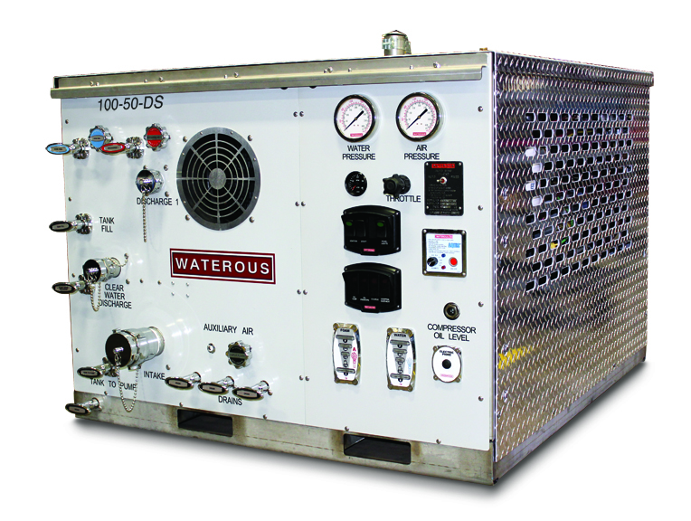

Frame:
High-strength, stainless steel frame

Warranty
Waterous Five-Year Limited Warranty

Conditions of Sales

For details on Waterous Conditions of Sales, refer to F-2190, Conditions of Sales located on the Waterous web site at www.waterousco.com or by contacting Waterous.

Industry Leading Sales and Support

When you purchase equipment, not only do you get quality products, you get quality service. Our expert service technicians are the best in the business and they are always happy to answer any service questions you might have.
Sales/Applications Assistance Service Assistance
Phone: 651-450-5234 (Press 3) Phone: 651-450-5200
pumpsales@waterousco.com Fax: 800-488-1228
service@waterousco.com

RAISING THE BAR ON INNOVATION, RELIABILITY AND SERVICE.
SPECIFICATIONS – Slide-in cafsystems: 100-50-DS

Air Compressor:
The air compressor is an oil-flooded, rotary screw type, sized to supply a minimum of 50 scfm (1.4 m³/min) of usable air.
Pneumatic Modulating Inlet Valve:
The air compressor is controlled by the pneumatic modulation inlet valve mounted on the air end. The pneumatic modulation inlet valve controls air delivery while maintaining constant pressure.
Auto Sync Balancing System:
Automatically maintains the air pressure within +/- 5% of the water pump pressure throughout the pressure range. The Auto Sync Balancing System is located on the operator's panel and allows for the following modes:
- Automatic - Air pressure matched to water pressure
- Fixed - Air pressure defaults to manual setting on compressor mounted control valve.
- Unload - Air pressure reduced to 40 psig (2.8 bar) for standby operations
Air Compressor Oil System:
A spin-on, full-flow oil filter unit is part of the system to control oil flow to the cooler. All lines are routed in braided hose conforming to SAE 100R1 standards for hydraulic hose.
Modular Air/Oil Separator:
Replacement elements for the oil filter and separator are available.
Air Compressor Cooling System:
The air compressor is cooled by a 12 or 24 V electric / air fan type cooler. This design eliminates the concerns of freezing of a traditional water type cooler. The system maintains recommended operating temperatures throughout the full operational range in ambient temperatures up to 115°F (46.1° C).

Options:
- On-Site Delivery Instruction - Contact factory for pricing.
- Top and Side Enclosures
Air Lines:
All air lines are rated to a minimum of 250 psig (17.2 bar). Air line fittings are constructed of brass, bronze or steel. Stainless steel or brass check valves are provided at all air injection points to prevent water back-flow into the air lines. All hoses shall be secured to the frame with insulating clamps and located away from any heat sources.
Plumbing:
Inlet:
Inlet piping is 2” stainless steel pipe with a 2” tank to pump valve controlled at the pump panel. An inline strainer is also provided. A 2” valve is provided behind the pump panel for overboard pump inlet with a 1.5” M-NST connection. Victaulic-type couplings are utilized in the pump inlet for flexibility and improved serviceability.
Discharge:
Plumbing to two panel mounted 1.5” discharge outlets incorporate a stainless steel manifold, welded stainless steel pipe and/or Class 1 high-pressure hydraulic hose with stainless steel fittings. A 1” tank fill provision with 1” valve is provided. Victaulic-type couplings are utilized in the discharge plumbing for flexibility and serviceability. All discharge plumbing is designed and tested to a minimum of 500 psig (34.5 bar) burst pressure.
Drains:
Panel mounted drain valves are provided to drain water from the water pump, discharge manifold and compressor cooler.
Foam Proportioner:
- Aquis™ Foam Proportioner with operator interface terminal (OIT), pump module with electric motor/motor driver and microcontroller unit, foam concentrate strainer, shielded electrical cables for connection of all electronic components, foam inject check valve, WYE Strainer and flowmeter and tee.

