SPECIFICATIONS – Slide-in cafsystem: 100-50-OS
ONE STEP™ CAFSystem – Designed for Easy Operation

Benefits of Compressed Air Foam
- 80% of water content in the foam is
effectively used for fire fighting
- Improved firefighter safety
- Faster knockdown time
- Less property damage
- Less water used

The 100−50−OS is a slide−in modular compressed air foam unit designed and constructed to discharge water, foam solution, compressed air foam or air only. To further enhance the 100-50-OS, the Waterous ONE STEP™ CAFSystem is configured into the system to provide continuous, homogenous and repeatable foam every time the system is used.

100-50-OS Performance
 | FLOW |  |  | PRESSURE
 | GPM | l/min | l/sec | PSI | bar | kPa | MPa
Water Flow | 100 | 400 | 6.5 | 150 | 10 | 1000 | 1.0
 | CFM | M³/Min |  | PSI | Bar | kPa | MPa
Air Flow | 50 | 1.4 |  | 100 | 7 | 700 | 0.7

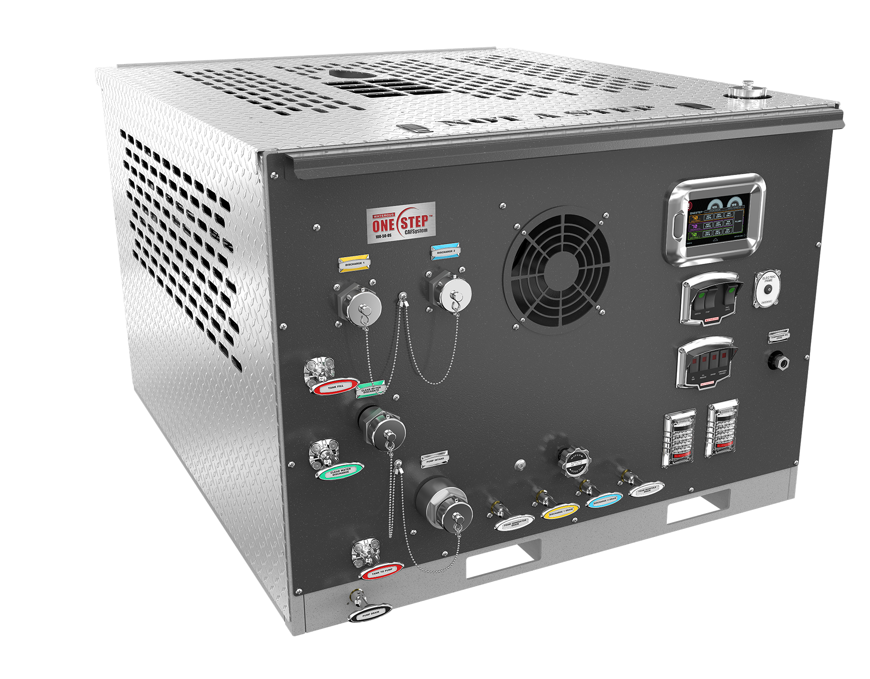

ONE STEP™ CAFSystem
- Two 1-1/2” Foam Generators
- 50 SCFM GHH-Rand Air Compressor
- Aquis™ 1.5 Foam Proportioner w/Electronic OIT
- 7” Digital Control System

Pump / Transmission Specifications
- Waterous CPD-2 Centrifugal water pump, aluminum case, double-hubbed bronze impeller, stainless steel shaft and maintenance-free mechanical seal.
- 3-inch NPT Intake
- 2-inch NPT Discharge
- Venturi Primer w/electric activation switch
- “Poly Chain” drive transmission with an automatic tensioner and 8mm pitch sprockets.

Engine Specifications
- Deutz, two-cylinder, air/oil-cooled, delivering a maximum of 30 HP (22.5 kW), four-cycle, diesel fueled. Two (2) year manufacturer's warranty.
- The engine uses a pulse fuel pump (fuel tank not supplied).
- Pressure lube system with spin-on oil filter. An extension hose is installed on the engine oil drain with a valve located at the oil pan and a plug installed in the end of the hose to facilitate oil changes.
- 12 or 24-volt electric with 40A alternator, electric ignition and start switch.
- Spark Arrestor Muffler
- Cold start aid option available
Pump Operator's Panel:
- 7” Digital Control Panel
  - Engages Pump and Compressor
  - Engages the ONE STEP™ CAFSystem
  - Select from Dry or Wet Foam
  - Monitor Intake and Discharges
  - Monitor Engine / Pump Performance
  - Electronic throttle advances to desired discharge pressure automatically
- Chrome-plated discharge connection
- Venturi priming system w/push to prime activation
- Auxiliary compressed air outlet and valve control
- LED Lighting
- I/C Push-Pull valve actuators



Frame:
High-strength, stainless steel frame

Warranty
Waterous Five-Year Limited Warranty

Conditions of Sales

For details on Waterous Conditions of Sales, refer to F-2190, Conditions of Sales located on the Waterous web site at www.waterousco.com or by contacting Waterous.

Industry Leading Sales and Support

When you purchase equipment, not only do you get quality products, you get quality service. Our expert service technicians are the best in the business and they are always happy to answer any service questions you might have.
Sales/Applications Assistance Service Assistance
Phone: 651-450-5234 (Press 3) Phone: 651-450-5200
pumpsales@waterousco.com Fax: 800-488-1228
service@waterousco.com

SPECIFICATIONS – Slide-in cafsystems: 100-50-OS

Air Compressor:
The air compressor is an oil-flooded, rotary screw type, sized to supply a minimum of 50 SCFM (1.4 m³/min) of usable air.
Air Compressor Oil System:
A spin-on, full-flow oil filter unit is part of the system to control oil flow to the cooler. All lines are routed in braided hose conforming to SAE 100R1 standards for hydraulic hose.
Modular Air/Oil Separator:
Replacement elements for the oil filter and separator are available.
Air Compressor Cooling System:
The air compressor is cooled by a 12 or 24 V electric / air fan type cooler. This design eliminates the concerns of freezing of a traditional water type cooler. The system maintains recommended operating temperatures throughout the full operational range in ambient temperatures up to 115°F (46.1° C).

Air Lines:
All air lines are rated to a minimum of 250 psig (17.2 bar). Air line fittings are constructed of brass, bronze or steel. Stainless steel or brass check valves are provided at all air injection points to prevent water back-flow into the air lines. All hoses shall are secured to the frame with insulating clamps and located away from any heat sources.
Plumbing:
Inlet:
Inlet piping is 2” stainless steel pipe with a 2” tank to pump valve controlled at the pump panel. An inline strainer is also provided. A 2” valve is provided behind the pump panel for overboard pump inlet with a 1.5” M-NST connection. Victaulic-type couplings are utilized in the pump inlet for flexibility and improved serviceability.
Discharge:
Two (2) 1.5” CAFS discharges and one (1) 1.5” clear water discharge are standard. Additional discharge ports are standard on the discharge manifold. Stainless steel manifold, welded stainless steel pipe and high-pressure hydraulic hose with stainless steel fittings are provided. A 1” tank fill provision with 1” valve is provided. Victaulic-type couplings are utilized in the discharge plumbing for flexibility and serviceability. All discharge plumbing is designed and tested to a minimum of 500 psig (34.5 bar) burst pressure.
Drains:
Panel mounted drain valves are provided to drain water from the water pump and discharge manifold.

ONE STEP™ CAFSystem
ONE STEP™ CAFSystem uses a stand-alone “Compact Foam Generator” (CFG) for each simultaneously operated discharge outlet. These are specially developed and patented devices in which the ONE STEP extinguishing agent will be generated. These foam generators include all necessary elements such as:

- Volume flow regulation of water and air
- Volume flow limitations of water and air
- Non-return valves for water and air
- Mixing chamber
- Mixing pressure control valve
- Wet-dry changeover

A characteristic of each ONE STEP™ CAFSystem is the pre-set flow rate and pre-set pressure for water and air. The operator does not have to adjust flows and pressures during operation.

Aquis™ Foam Proportioner
Aquis™ Foam Proportioner with pump module with electric motor/motor driver and microcontroller unit, foam concentrate strainer, shielded electrical cables for connection of all electronic components, foam inject check valve, WYE Strainer and flowmeter and tee.

7” Digital Control Panel
Key Factors:
- One-Button Operations
- Engages entire ONE STEP™ CAFSystem
- Master discharge PSI gauge and individual discharges are integrated into the System.

Options
- On-Site Delivery Instruction – Contact Waterous for Pricing.
- Top and Side Enclosures
- Poly Tank with booster reel mounting blocks and IC water level gauge
  - Available Sizes:
    - 200 Water / 10 Foam
    - 250 Water / 10 Foam
    - 250 Water / 20 Foam
    - 300 Water / 10 Foam
    - 300 Water / 20 Foam

- Aquis™ 2.5 or Advantus® 3 Foam Systems

RAISING THE BAR ON INNOVATION, RELIABILITY AND SERVICE.

