
SPECIFICATIONS: tellurus™ HMI

Display Features

- a-Si Active Matrix LCD
- 1300 cd/m2 High-bright Backlight
- Direct Sunlight Readability
- 700:1 High Contrast Ratio
- 80º Viewing Angle
- Ambient Light Sensing
- Multi-point Glass Resistive Touchscreen
- Gloved Operation In Water Spray Environment
- Chemically Strengthened Glass Micro-sheet
- Impact Resistant
- Circular Polarizing Filter
- Anti-reflective Coating
- Dry-Film Optical Bonding

Graphic Architecture

- 24-bit Truecolor
- Intel® HD Graphics DX11, Open GLE ES 3.0

Embedded Controller

- Intel® Atom® Dual-core Processor @ 1.75GHz
- 2MB L2 cache
- 2GB DDR3 DRAM (expandable to 8GB)
- 8GB SLC SATA SSD (expandable to 128GB)
- Real-Time ClockWaterous Five-Year Limited Warranty

OS Software
- WindRiver® Linux 5.0
- Intel® IDP 2.0 WAN Security
- McAfee® Embedded Control

Environmental Protection
- -40C to +85C Operating Temperatures
- Water resistant to IP67
- Vibration to MIL-STED-810G for Ground Based Motor Vehicles

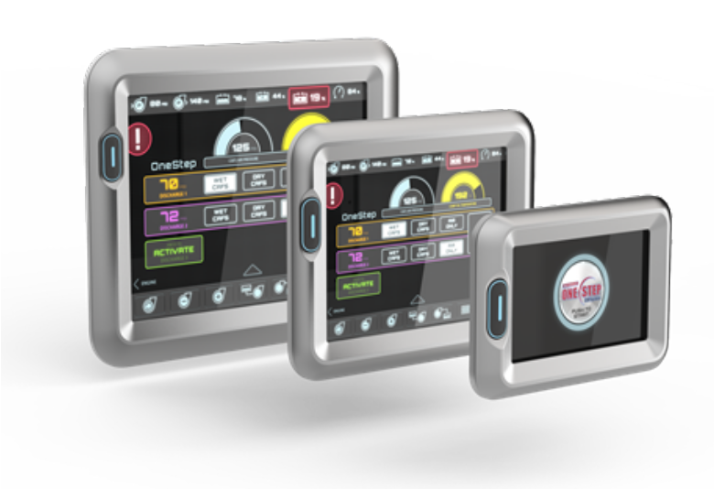

®
Powered By

Pump Specifications

Device Connectivity
- 2 x Ethernet IEC 61067–2–101, 4-pin, M12, 10/100 Base-T
- Secure Networking VPN: IPSEC/PPTP/L2TP
- Sealed M12 Mini Hi-Speed USB 2.0 Host Port
- Bluetooth 4.0 With BLE Support
- Integrated 802.11 a/b/g/n WiFi, Host-AP and Client Mode Support
- Open Mobile Alliance Device Management (OMA DM)
- WebIF Web-based Configuration
- Accelerometer
- 12 Channel GPS Receiver (optional)
- WiFi dual Band / GPS Antenna (optional)
- GSM/GPRS/CDMA 3G/4G LTE Cellular Modem (optional)

Power Supply
- 9-32VDC Transient Protected
- Power Consumption < 15W

®

Intel® Gateway Solutions for the Internet of Things (IoT)
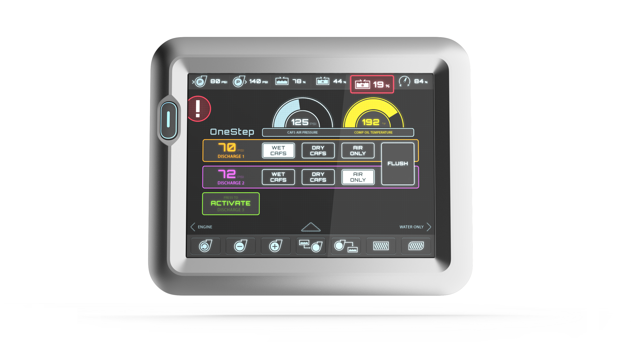
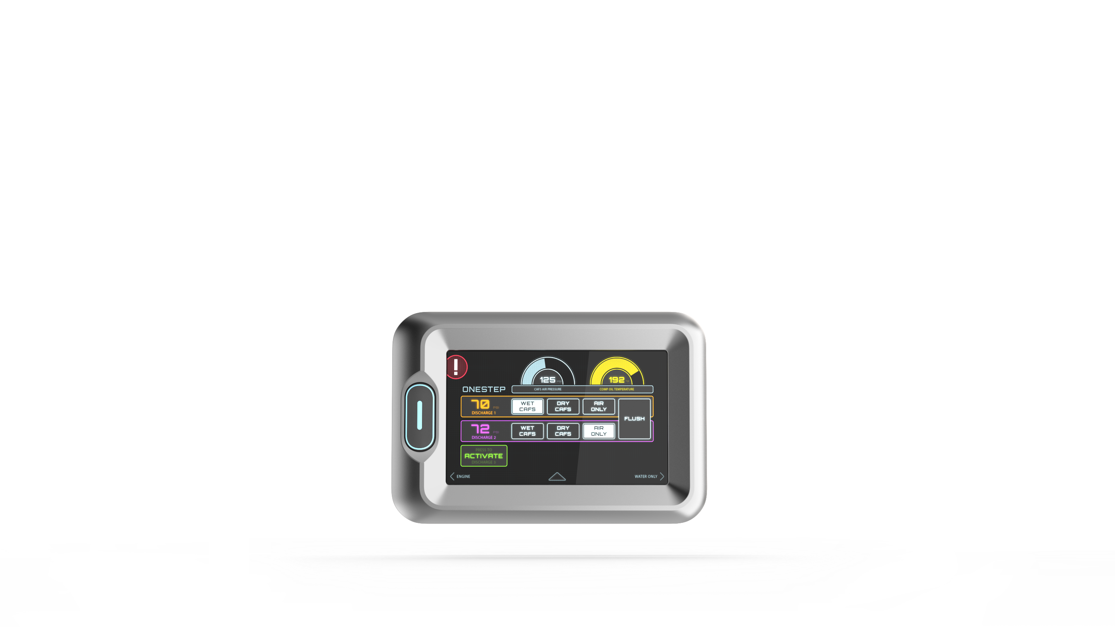
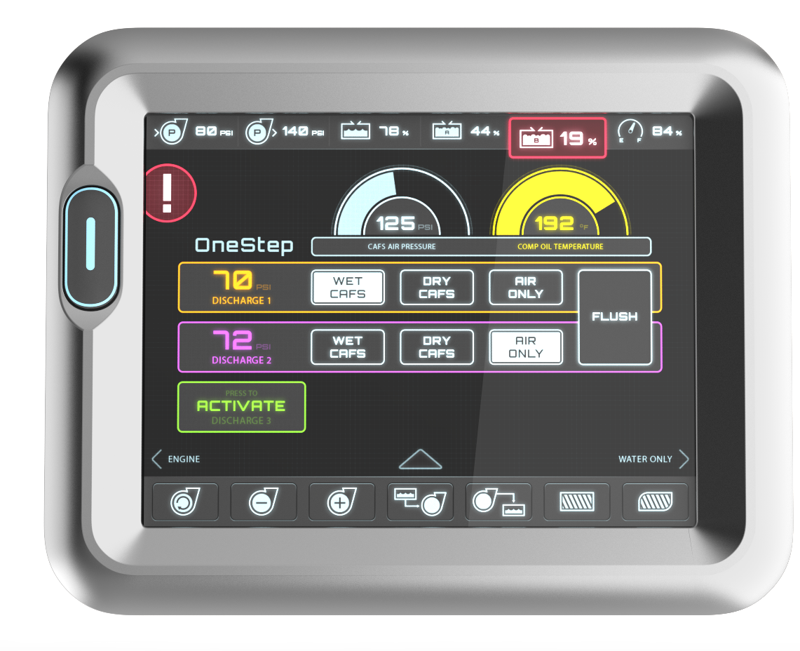
TELLURUS™ 7” HMI TELLURUS™ 10” HMI TELLURUS® 15” HMI
7.0-inch Diagonal Screen Size
WSVGA (1024 X 600) Resolution
15.0-inch Diagonal Screen Size
SVGA (1024 X 768) Resolution
10.4-inch Diagonal Screen Size
SVGA (1024 X 768) Resolution

