

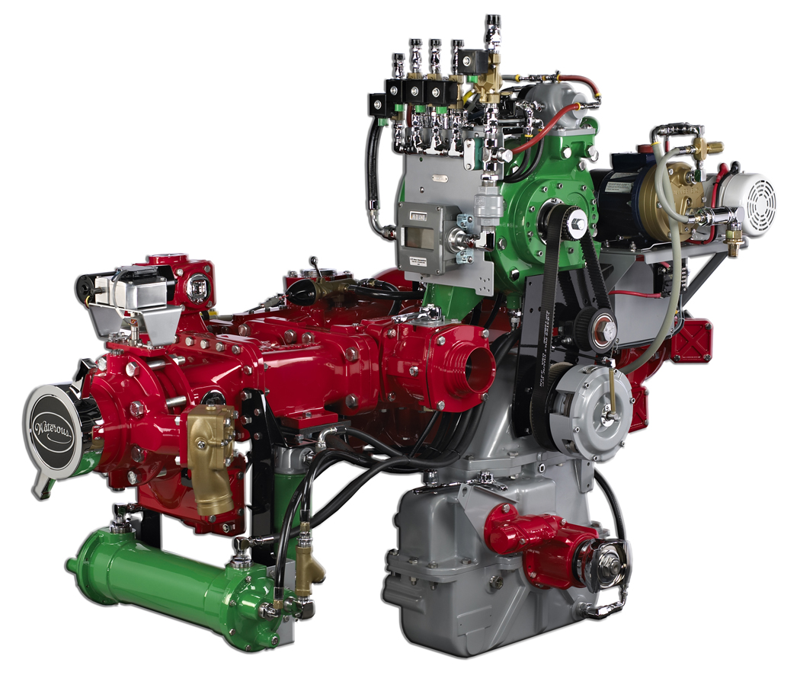
SPECIFICATIONS – cafsystems: eclipse™
Compressed Air Foam Systems That “Eclipse” Fires

Considered to be the world’s premier CAFSystem™, the Waterous Eclipse™ integrated midship-mounted unit is designed for total versatility. Simplify maintenance and get reliable performance with this durable powerhouse. The Eclipse is currently available on Waterous CS, CSU and CMU midship pumps with split-shaft transmissions. Delivering 200 SCFM of individually adjustable compressed air, aspirated foam and water (all at the same time depending on configuration), the Waterous Eclipse provides faster knockdown times, less property damage and less risk to your firefighters. The Eclipse is also backed by an industry exclusive five-year warranty and free-onsite product instruction.

Description:

When it comes to compressed air foam systems, nothing can match Eclipse™. Eclipse incorporates a powerful integrated midship-mounted air compressor system and revolutionary Advantus™ Foam Management System, creating a package that delivers maximum versatility, simple maintenance and reliable performance.
The Eclipse is backed by an industry exclusive 5-year warranty and free onsite product instruction.

The benefits of Compressed Air Foam are well documented:
- Less risk to the firefighter
- Faster knockdown time
- Less water used
- Less property damage

The Eclipse Compressed Air Foam System is currently available on Waterous CS, CSU and CMU midship pumps with split-shaft transmissions.

Eclipse CS Flow Specs:
750, 1000 and 1250 GPM @ 150 psi
(2850, 3800 and 4750 l/min @ 10.3 bar)

Eclipse CSU Flow Specs:
1250 to 2250 GPM @ 150 psi
(4750 to 8550 l/min @ 10.3 bar)

Eclipse CMU Flow Specs:
1250 to 2250 GPM @ 150 psi
(4750 to 8550 l/min @ 10.3 bar)

Eclipse delivers:
- Sold, serviced and warranted through Waterous
- Advantus® Foam Management System is pre-plumbed, pre-mounted and pre-calibrated (2-year warranty).
- Optional proportioners available.
- Exceeds NFPA 1901 requirements for proportioning accuracy
- Quiet, efficient and dependable rotary screw air compressor systems
- Pneumatic clutch can be engaged or disengaged with pump running
- Toothed-belt drive requires no lubrication or maintenance
- Digital air flowmeter readout
- Aspirated foam or 200 SCFM compressed air foam
- System is fully calibrated before shipment
- All components mounted to the midship pump saving valuable compartment space
- Simplifies troubleshooting and maintenance
- User training provided

Operation Instruction
Up to three day of CAFS operation and maintenance instruction shall be provided. The instruction shall take place at the user's facility with 30 days of apparatus delivery.
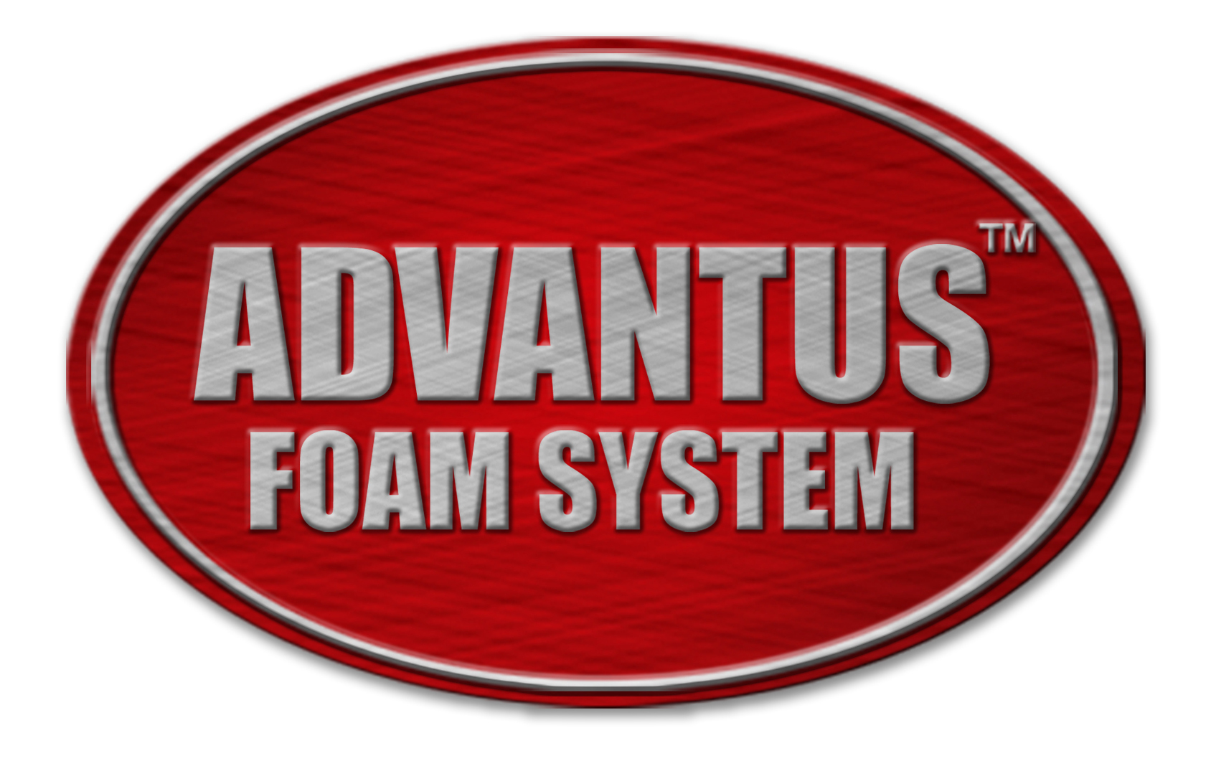

Industry-Leading Sales and Support

When you purchase Waterous equipment, not only do you get quality products, you get quality service. Our expert service technicians are the best in the business and they are always happy to answer any service questions you might have.
Sales/Applications Assistance Service Assistance
Phone: 651-450-5234 (Press 3) Phone: 651-450-5200
pumps@waterousco.com Fax: 800-488-1228
service@waterousco.com

SPECIFICATIONS – cafsystems: eclipse™

Air Compressor
The air compressor is an oil-flooded, rotary screw type sized to supply a minimum of 200 CFM of free air at a minimum of 125 P.S.I.G. The compressor is encapsulated within its own sump/pressure vessel with an oil level indicator, air pressure relief valve and threaded fill cap/plug.
Pneumatic Modulating Inlet Valve
The air compressor is controlled by the pneumatic modulation inlet valve mounted on the air end. The pneumatic modulating inlet valve controls air delivery while maintaining constant pressure.
Electric Auto-Sync Balancing System
Automatically maintains the air pressure within +/- 5% of the water pump pressure throughout the pressure range. The Electric Auto-Sync Balancing System is located on the operator's panel and allows for the following modes:
- Automatic - Air pressure matched to water pressure
- Fixed - Air pressure defaults to manual setting on compressor mounted control valve. (Factory set at 150 P.S.I.G.)
- Unload - Air pressure reduced to 40 P.S.I.G. for standby operations
- Run - Air compressor in run operation. Air pressure determined by Auto or Fixed setting.
- Air Distribution Manifold
- An integrated air distribution manifold provides the following:
- 1/2” electrically controlled solenoid valve - minimum of four
- 3/4” electrically controlled solenoid valve - quantity of one
- 3/4” auxiliary outlet - quantity of one
Air Compressor Drive
The compressor is driven off the back of a standard Waterous pump transmission1. The compressor drive is engaged with a pneumatic activated “hot shift” clutch. Power is transferred via a synchronous drive “toothed belt” with an adjustable tensioner. The system is designated to operate the air end at rated capacity when the fire pump is developing 130 to 140 P.S.I.G. in a “no flow” state.
Clutch
High speed with HICO friction facings and shielded bearings
Air Compressor Oil System
A spin-on, full-flow oil filter unit and a thermostatic valve are all part of the system to control oil flow to the cooler. All oil lines are routed in braided hose conforming to SAE 100R1 standards for hydraulic hose.
Modular Air/Oil Separator Unit
Replacement elements for the oil filter and separator are available.
Air Compressor Cooling System
The air compressor is cooled by the Waterous fire pump¹, utilizing an all copper and brass shell and tube heat exchanger. When the fire pump is operating, water flows through the heat exchanger while an in-line removable strainer, on the water inlet side, prevents clogging. The system maintains oil temperature within 160° to 225°F.
Air Controls and Instruments
The following controls and instruments are to be located on the operator's panel:
- Air compressor clutch engagement switch with “ON” indicator light
- Electric Auto-Sync compressor controls (Auto/Manual, Run/Unload) with engraved instruction plate
- Air compressor temperature gauge with warning light and audible alarm
- CAF system air pressure gauge
- Digital air flow meter (SCFM)
- An “ON/OFF” air supply switch for each compressed air foam discharge (controls to be adjacent to and color coded with respective water valves)
Foam Concentrate Piping
All concentrate piping is stainless steel, brass or high pressure wire braid reinforced hose with stainless steel or brass fittings.
Foam Manifolds
Foam manifolds are constructed of heavy cast iron. The manifold is a fully integrated assembly with foam injector port, flow meter mount and high-flow, low-loss, spring-assisted check valve to prevent back-flow of foam concentrate or foam solution into the pump.
Foam Discharges (Included with 500 GPM Eclipse Only)
Foam discharges are to be equipped with brass or stainless steel check valves on the water/solution plumbing to isolate the individual discharges and prevent back-flow of air or CAF into the pump or neighboring discharges.
Static Mixer
The static mixer of stainless steel construction is incorporated into the plumbing of the master stream discharge for optimal foam quality.
Foam Management System - Advantus™
A fully automatic electronic direct foam injection system is furnished and installed. The system is capable of Class A foam concentrates and most Class B foam concentrates. The system includes the following:
Digital Electronic Control Display
Located on the pump operator's panel, the electronic control display enables the operator to perform the following functions:
- Provide push-button control of foam proportioning rates from 0.1% to 1%, in 0.1% increments; 3% and 6%
- Show current flow-per-minute of water
- Show total volume of water discharged during and after foam operations are completed
- Show total amount of foam concentrate used
- Show which foam supply tank is in use
- Perform setup and calibrate functions for the microcontroller
- Flash a “low concentrate” warning when the foam concentrate tank(s) run(s) low
- Flash an “error” warning with associated code in the event of an electronic malfunction
- Provide a manual back-up mode, controlled by the operator
12 or 24-Volt Electric Motor
A 12 or 24-volt electric motor driven Hydra-Cell positive displacement foam concentrate pump, rated at 3 GPM @ 150 psi (11.3 l/min @10 bar) or 6 GPM @ 150 psi (22.6 l/min @ 10 bar) and with operating pressures up to 450 psi (32 bar).

For more information on the Advantus™ Foam Management Systems, see Specification Sheets F-2598 or F-2599. Also see F-2597, Foam Management Systems.

¹See F-1145, “Waterous CMU Series Fire Pumps”, F-1195, “Waterous CS Series Fire Pumps” or F-1174, “Waterous CSU Series Fire Pumps” specification sheets for more information on Waterous mid-ship centrifugal fire pumps.

