SPECIFICATIONS – motor pumps: PB18-3030
Your First Choice for Water Transfer/Hand-Line Operations


The PB18-3030 is an extraordinary transfer and supply pump with exceptional flow capacity and good pressure for hand-line operations. Equipped with a V-twin Briggs and Stratton® 18 HP engine, the PB18-3030 delivers from 100 GPM @ 110 PSI (380 L/min @ 7.6 bar) to 400 GPM @ 15 PSI (1500 L/min @ 1 bar). The PB18-3030 also comes with a two-year warranty and is CE marked*.
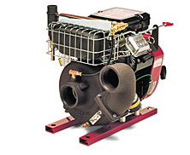
NOTE: PB18-3030C models equipped with Wrap-Around Bases are CE Marked.

Pump Specifications:

Type: Transfer - Supply
Intake: 3 inch female NPT
3 inch female BSP tapered
Discharge: 3 inch female NPT with check valve (3030C)
3 inch female NPT, forward facing, no check valve (3030E)
3 inch female BSP tapered w/check valve (3030C)
3 inch female BSP tapered, forward facing, no check valve (3030E)
Console:
Operator's panel includes discharge pressure gauge, compound intake pressure gauge, low oil pressure warning light, start and stop control, speed control, panel light and 12 volt outlet.
Volute Body and Head:
High-strength aluminum alloy, anodized for superior corrosion resistance.
Impeller:
High-strength, corrosion-resistant bronze, fully-enclosed, double-hubbed to balance hydraulic thrust, mechanically balanced to eliminate vibration.
Wear Rings:
Long wearing bronze. Easy to replace when required to restore original pump efficiency.
Shaft Sleeve:
High-strength stainless steel.
Shaft Seal:
Spring-loaded mechanical type.
Priming:
Combination spark arresting muffler and exhaust primer, fast and easy to use. Quarter turn bronze priming valve, operates with push/pull knob. Standard on wrap-around bases. Optional on no base and rail base.

Engine Specifications:
Engine:
Briggs & Stratton, model 356447, Vanguard V-Twin air cooled, overhead valve (OHV) design delivers a maximum output of 18 HP (13.4 kW) @ 3600 RPM. 34.75 cu. in. (570 cc) displacement, 4-cycle, gasoline fueled, horizontal shaft.
Lubrication:
Full pressure lubrication system with an automotive style oil filter. Oil fill tube with dipstick.
Starter:
12-volt electric and manual recoil.
Alternator:
16 A



Bases:
Rail (Standard):
Rigid steel channels. Control panel and fuel tank shipped loose.
No Base (Optional):
Control panel and fuel tank shipped loose.
Available for use outside USA and Canada:
Wrap-Around (Optional):
Tubular steel design to protect pump and engine from roll over damage. Swing away handles with vinyl grips that lock in either carry or stowed position. Includes control panel, battery tray and integral fuel tank with fuel level gauges. Optional mast light is available.

Fuel Tank:
Rail or No Base Models:
All PB18 models (except PB18-LE) with Rail or No Base will have a shipped-loose, 3-gallon (11 liter) fuel tank that meets the EPA evaporative requirement (40 CFR Part 1060).

Wrap-Around Base Models (not available in the USA or Canada):
PB18 models with Wrap-Around Base will have an integral 3-gallon (11 liter) fuel tank with fuel level gauge.

RAISING THE BAR ON INNOVATION, RELIABILITY AND SERVICE
RAISING THE BAR ON INNOVATION, RELIABILITY AND SERVICE
SPECIFICATIONS – Motor Pumps: PB18-3030

Approximate Dimensions and Weights

Base Type | Length (in/cm) | Width (in/cm) | Height (in/cm) | Dry Weight (lb/kg) | Ship Weight (lb/kg)
Rail | 19-3/4 (50.2) | 20 (50.8) | 21 (53.3) | 113 (51.3) | 141 (64.0)
Wrap-Around | 31 (78.7) | 20-1/2 (52.1) | 21-1/2 (54.6) | 135 (61.2) | 163 (73.9)
No Base | 19-1/2 (49.5) | 20 (50.8) | 20 (50.8) | 108 (49.0) | 136 (61.7)

Performance Curve

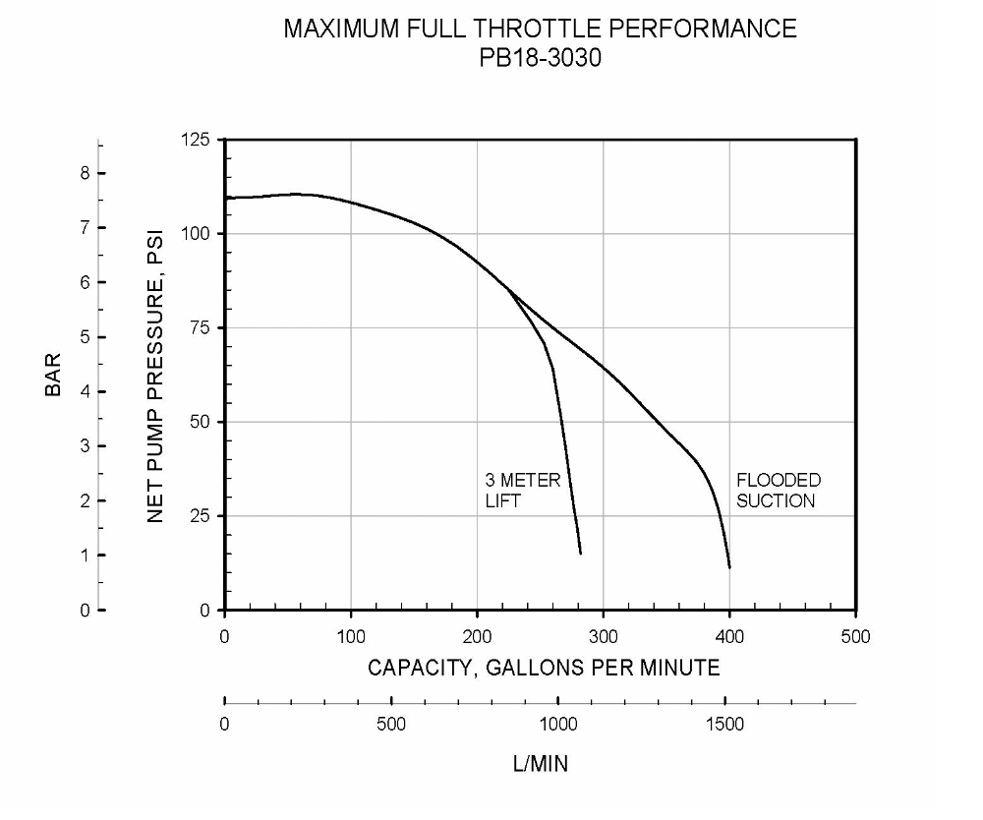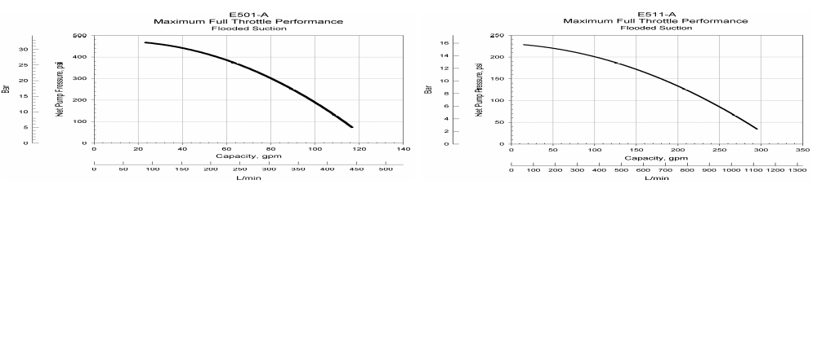

Industry-Leading Sales and Support

When you purchase Waterous equipment, not only do you get quality products, you get quality service. Our expert service technicians are the best in the business and they are always happy to answer any service questions you might have.
Sales/Applications Assistance Service Assistance
Phone: 651-450-5234 (Press 3) Phone: 651-450-5200
pumpsales@waterousco.com Fax: 800-488-1228
service@waterousco.com

