SPECIFICATIONS: Vehicle Mounted: cGV
Meets NFPA 1901 for 750 GPM and NFPA 1902 for 500 GPM


The combination of a single-stage design, vertically-split volute and pump transmission makes the Waterous CGV fire pump simple to operate and easy to maintain.

CGV Pump Performance
 | FLOW |  |  | PRESSURE
Rating | GPM | l/min | l/sec | PSI | bar | kPa | MPa
NFPA 1901 | 750 | 3000 | 50 | 150 | 10 | 1000 | 1.0
NFPA 1902 | 500 | 2000 | 30 | 150 | 10 | 1000 | 1.0
Special | 1000 | 4000 | 65 | 150 | 10 | 1000 | 1.0
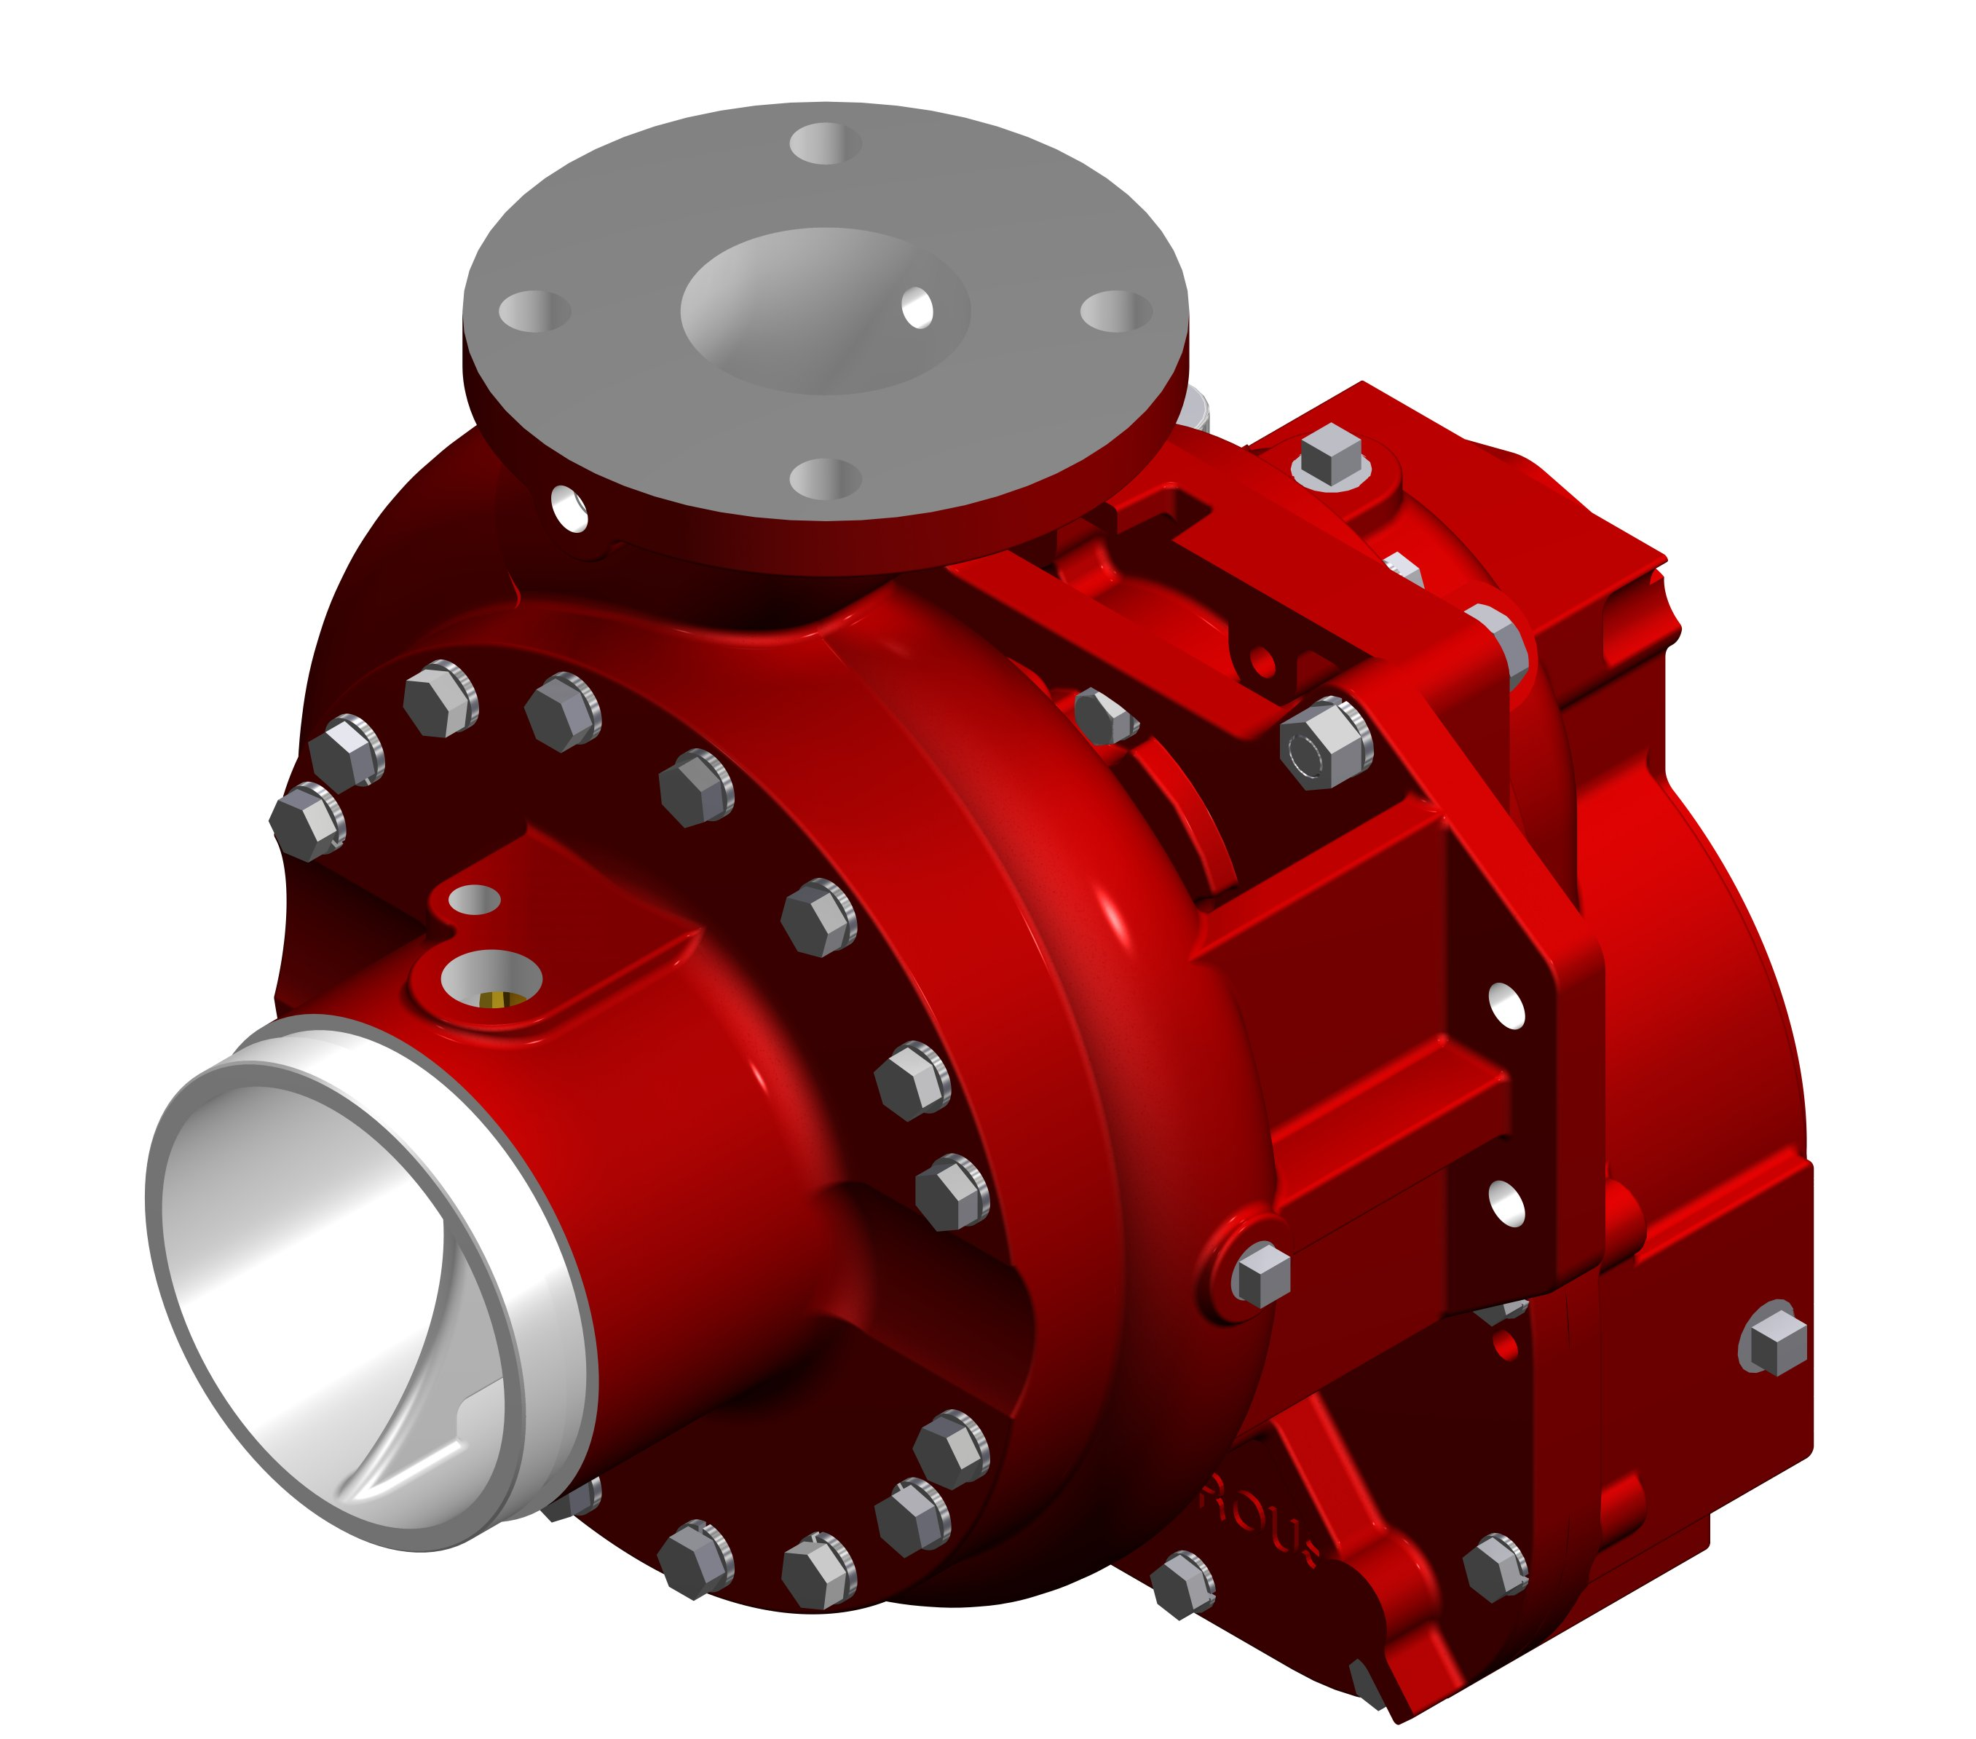

Pump Features
- Two-piece, vertically-split, high-tensile, close-grained gray iron, or bronze (optional).
- Self-Adjusting Mechanical Seal
- Replaceable bronze wear rings
- Stainless steel impeller shaft supported by oil-lubricated ball bearings.
- Bronze, double-hubbed impeller for smooth operation and longer life (Flame plating optional)
- 3” Flanged Discharge
- Rotation: Available in clockwise or counterclockwise rotation.
- Available with either threaded or Victaulic® intake connections. Threaded intake connections are available in three popular sizes. The CGV can also be used with a Victaulic® intake and discharge fittings for crash truck or fire boat use.
- Intake Fittings (Choice of the following):
Type | Model | Sizes
Threaded End Intake | CGVR | 4, 4-1/2 and 5 inch
Victaulic® Intake | CGV | 5 inch
Note: 4-1/2 inch threaded end intake available with either 2-1/2 inch or 3 inch auxiliary intake ports. All other fittings available with 2-1/2 inch auxiliary intake ports only. No auxiliary taps available on CGV pump.

Warranty

Waterous Five-Year Limited Warranty

Conditions of Sales
For details on Waterous Condition of Sales, refer to F-2190, Conditions of Sales located on the Waterous web site at www.waterousco.com or by contacting Waterous.

The S100 is backed by a Waterous Five-Year Limited Warranty.

For details on Waterous Conditions of Sales, refer to F-2190, Conditions of Sales located on the Waterous web site at www.waterousco.com or by contacting Waterous.

Optional Equipment (see next page)
- Priming System
- Pressure Control Systems – Discharge and Intake Relief Valves
- Corrosion Protection – Zinc Intake Screens and Anodes
- Overheat Protection Manager
- Drain Valves
- 3-1/2” Tank to Pump Valve
- Discharge Valves
- Pneumatic Shift
- Five-Year Limited Warranty with Total Protection Package (TPP-5)
- Tachometer drive, operates at ½ input shaft speed.
- Transmissions Available:

  - C20 Chain Drive (Split-Shaft)
  - P Series Chain Drive (PTO Driven)
  - K Series Gear Driven (PTO Driven)
  - T Series Gear Driven (Direct Engine)

Industry Leading Sales and Support

When you purchase equipment, not only do you get quality products, you get quality service. Our expert service technicians are the best in the business and they are always happy to answer any service questions you might have.
Sales/Applications Assistance Service Assistance
Phone: 651-450-5234 (Press 3) Phone: 651-450-5200
pumpsales@waterousco.com Fax: 800-488-1228
service@waterousco.com

RAISING THE BAR ON INNOVATION, RELIABILITY AND SERVICE.
SPECIFICATIONS: vehicle mounted: mODEL cgv

Pump Transmissions
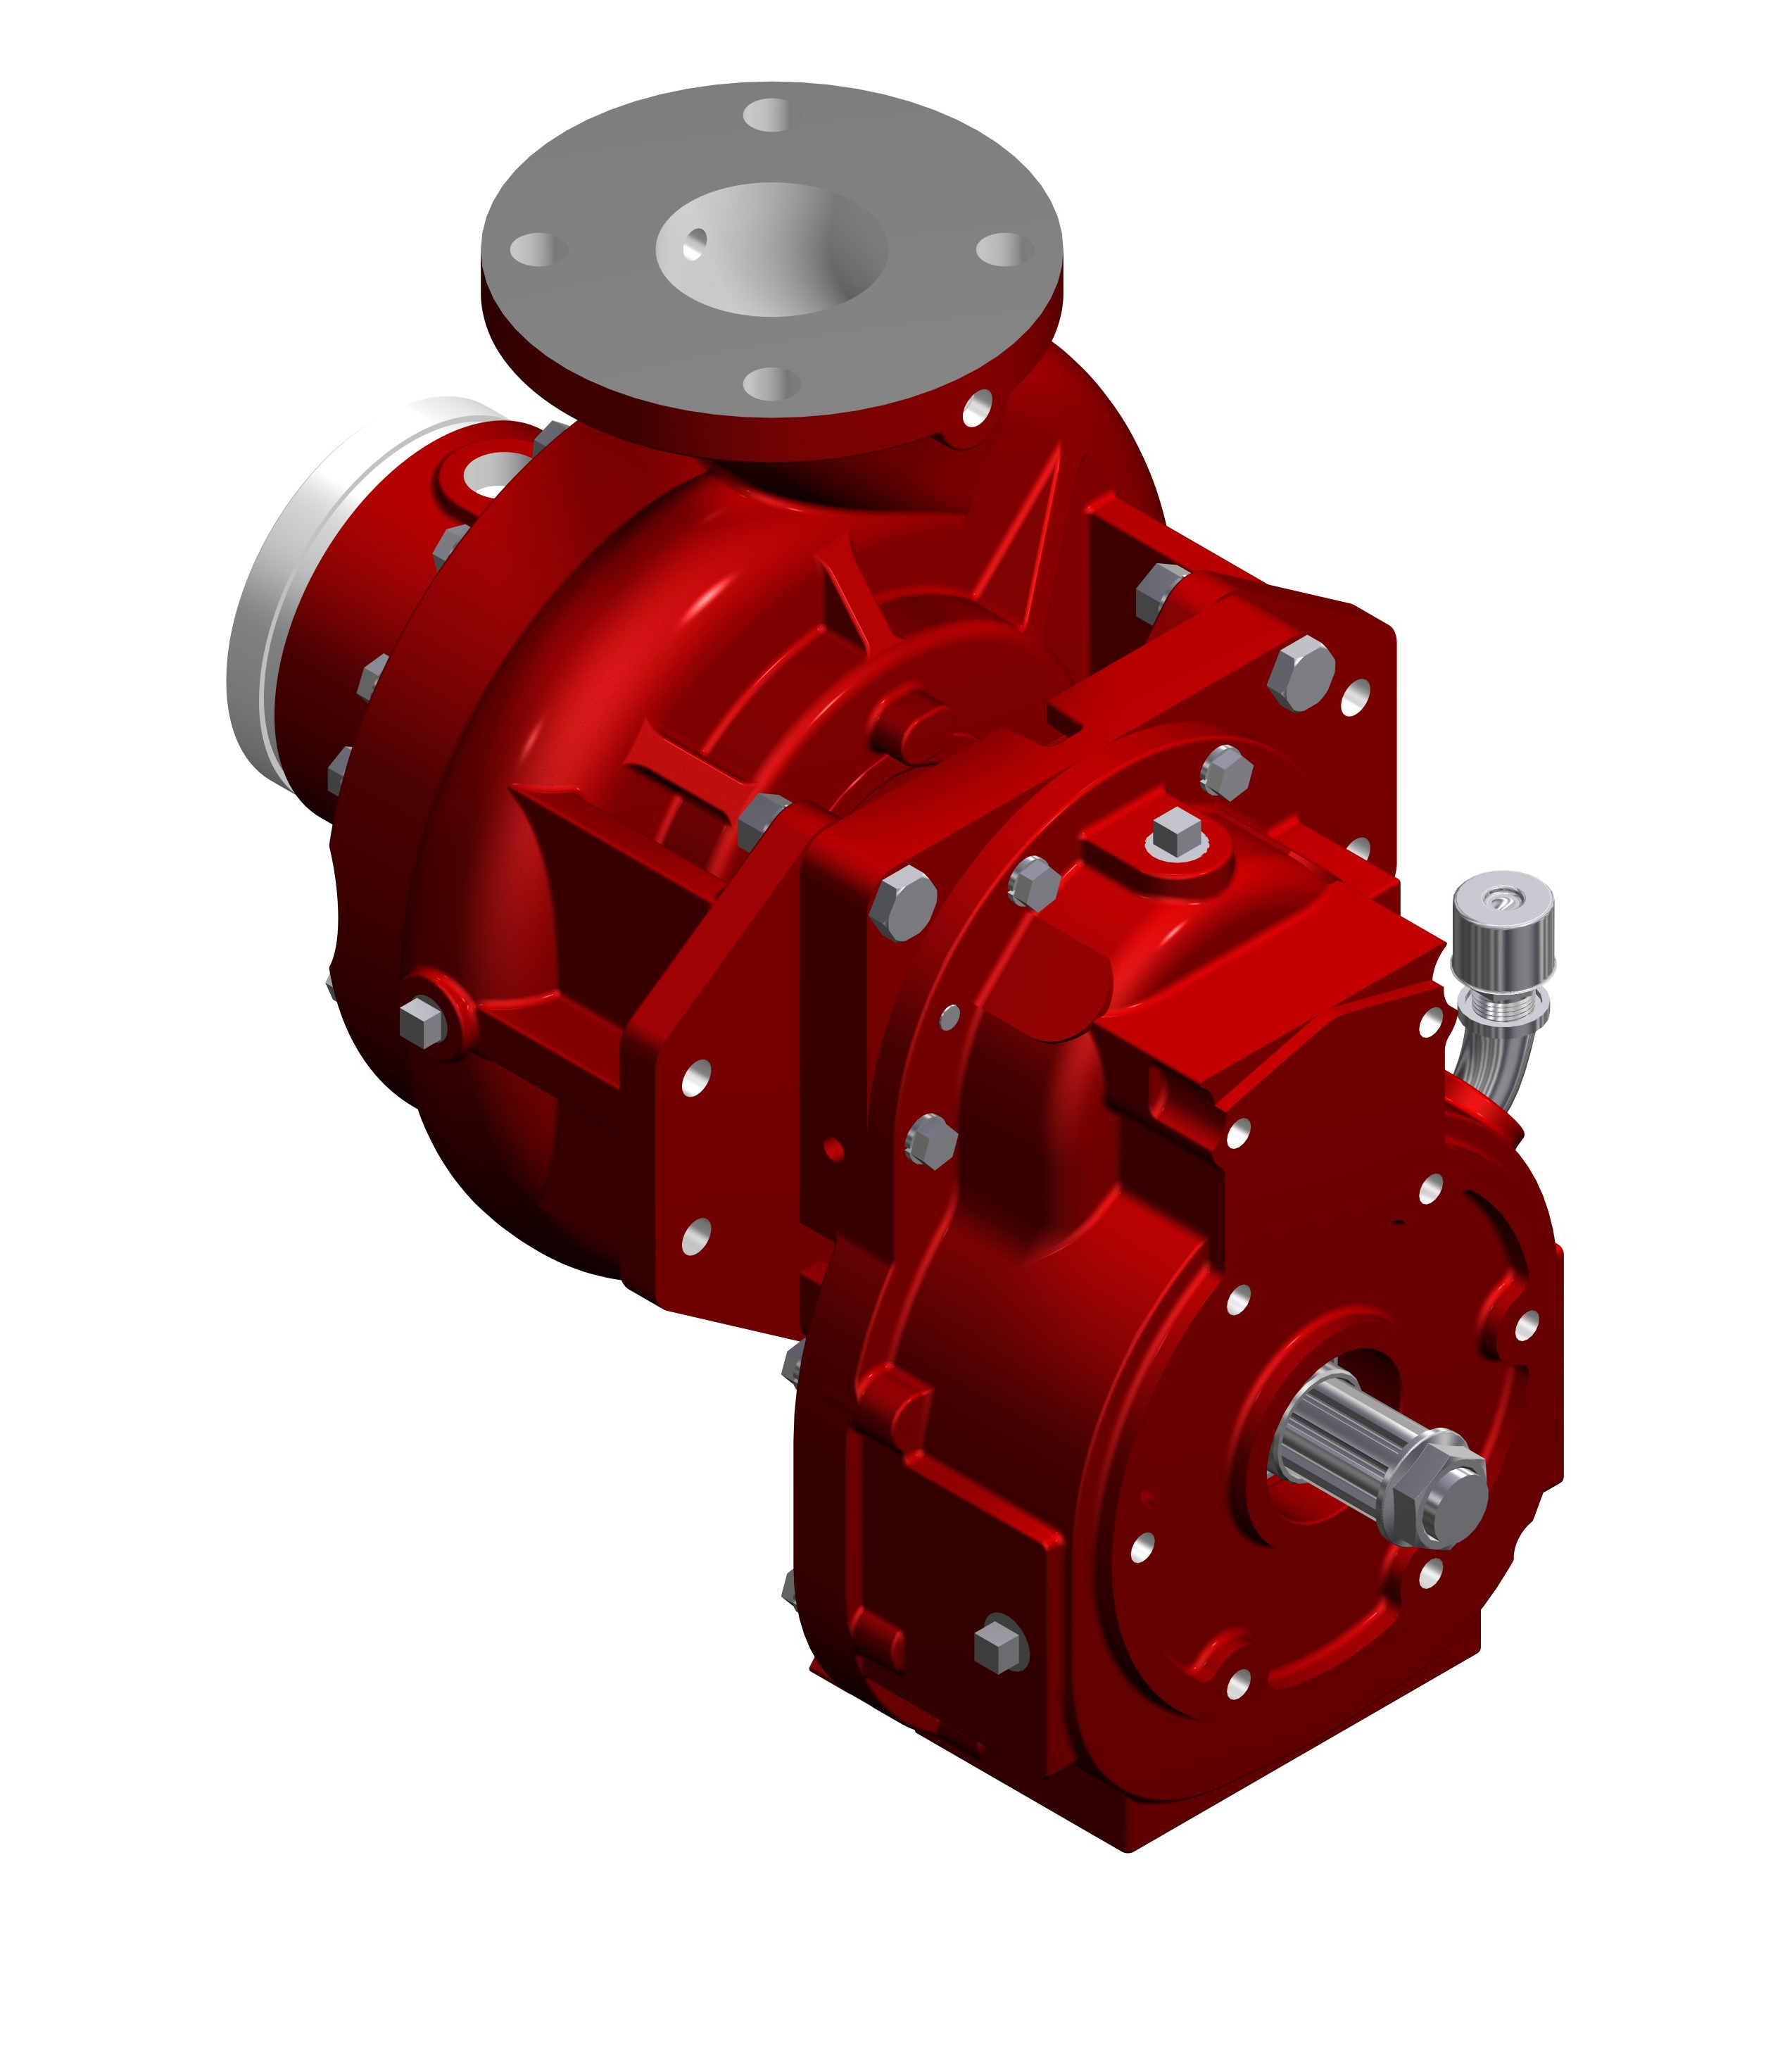
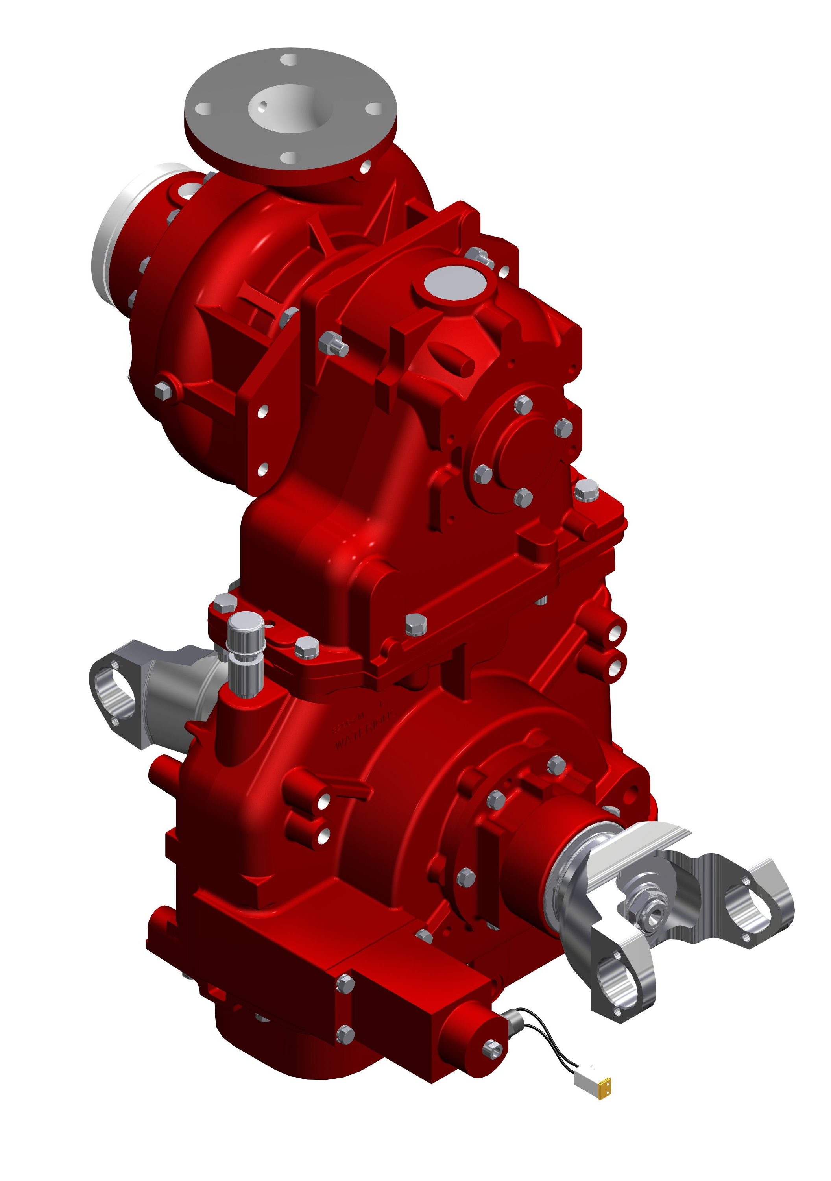

K Series
The K Series Transmission is normally used when a truck transmission mounted power take-off is selected as the pump drive.
Housing: Close-grained, gray iron
Gears: Helical, precision cut, crown shaved for proper load distribution and quiet operation.

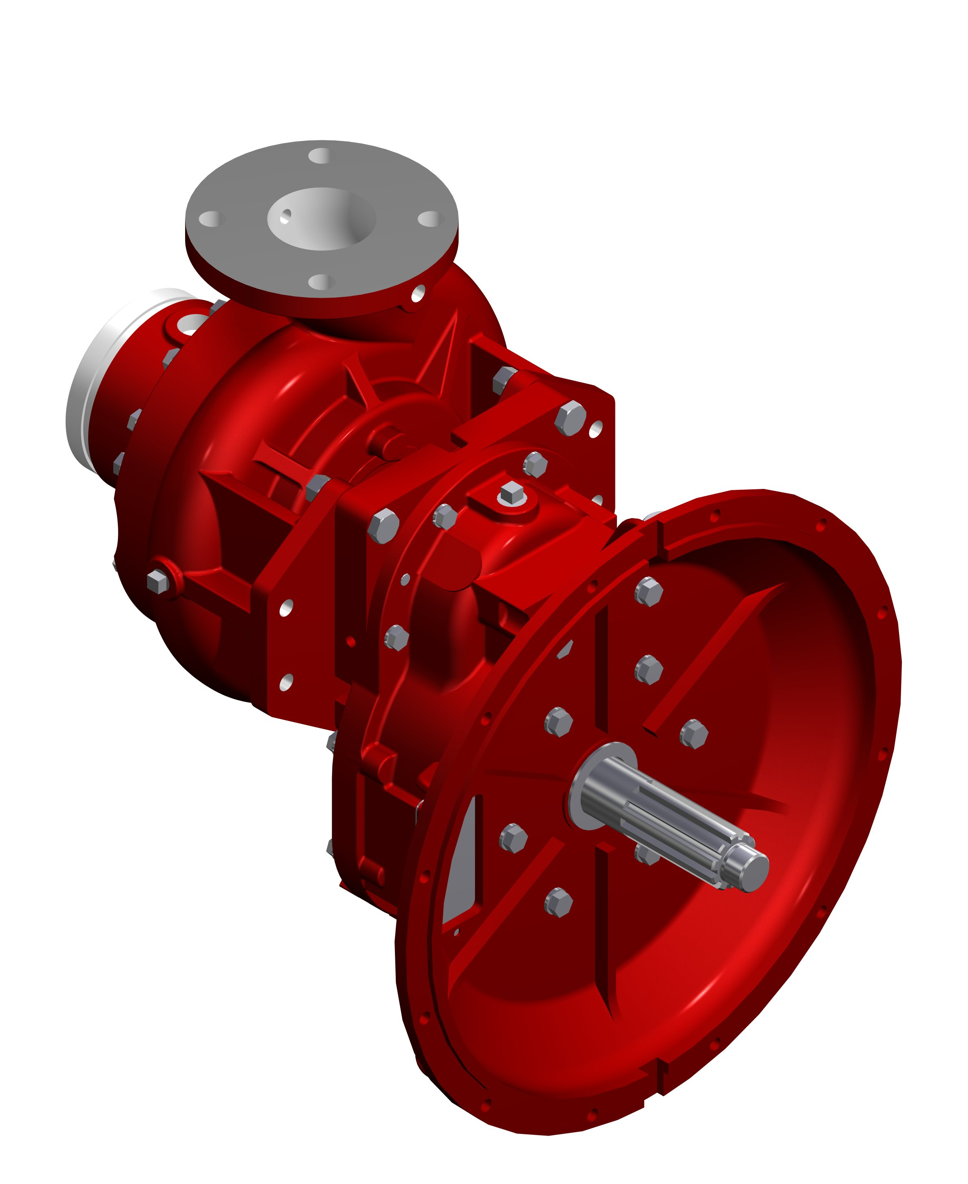
T Series
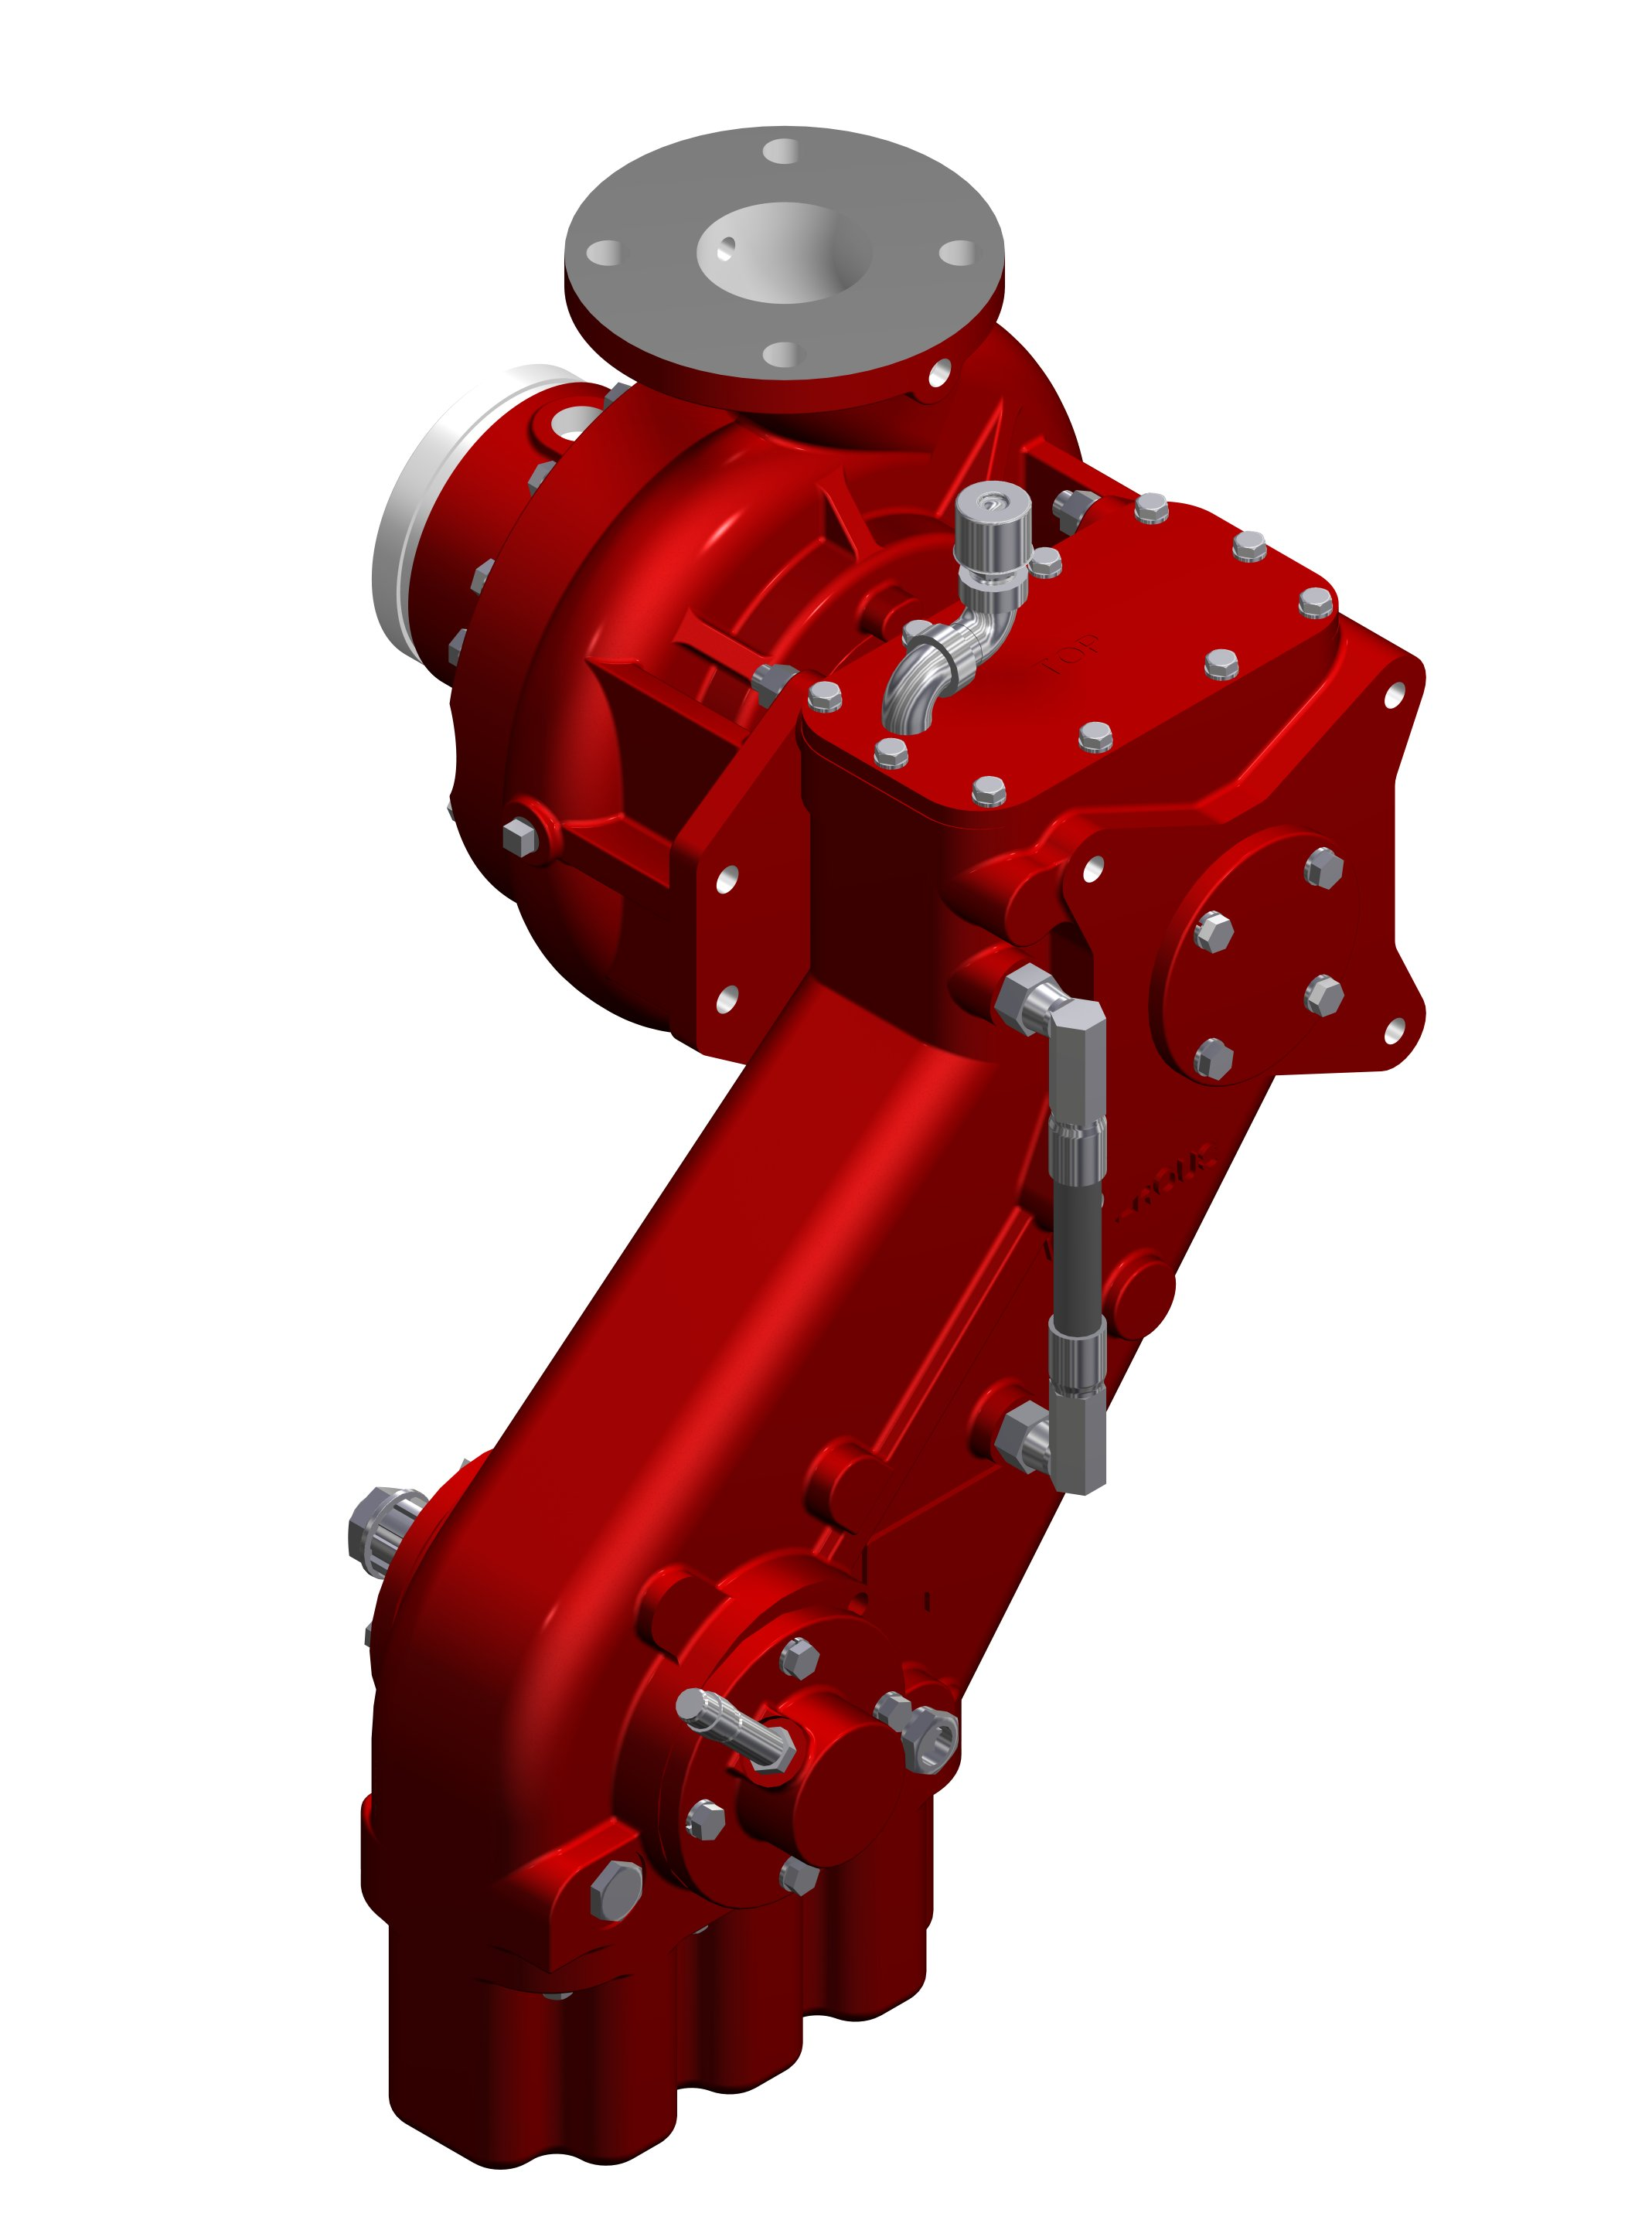
The T Series Transmission is supplied when the pump is to be mounted directly to the engine bell housing. This provides a clean, compact arrangement and allows for complete pump and roll capability.

T Transmissions are available in SAE 2, 3, 4, or 5 bell housing adapters.
Housing: Close-grained, gray iron
Gears: Helical, precision cut, crown shaved for proper load distribution and quiet operation.
C20 Series

The “C20” series transmission is supplied when the pump is to be midship mounted. Power from the truck's automatic transmission is transmitted to the pump.

Housing: High-strength aluminum
Chain: Morse HV®, high-strength involute chain

PA Series
PA Series transmission is normally used when a truck transmission mounted power take-off is selected as the pump drive. Designed for use with Allison transmissions with 10-bolt PTO.
Housing: High-strength aluminum

Chain: Morse HV®, high-strength involute chain

Pump Specifications

Casing:
Two-piece, vertically-split, high-tensile, close-grained gray iron, or bronze (optional).
Impeller:
Bronze impeller specifically designed for the fire service, double-hubbed to eliminate axial thrust, and accurately balanced for vibration-free running. Impellers with flame-plated hubs for extreme wear resistance are optional.
Wear Rings:
Replaceable bronze wear rings to increase pump life and keep maintenance costs at a minimum.
Impeller Shaft:
Stainless steel, heat treated, precisely ground to size, and polished under shaft seal. Supported by oil lubricated ball bearings.
Shaft Seal:
A face-type, self-adjusting, corrosion and wear resistance mechanical seal is standard.
Discharge:
3” flanged standard (optional 4” Victaulic)
Intake:
Available with either threaded or Victaulic® intake connections (see Table on previous page).

Accessories & Optional Equipment

The accessories below are available for Waterous CG pumps. For detailed information about these accessories, request each specification sheet by number.
Five-Year Limited Warranty with Total Protection Package (TPP-5)
The Five-Year Limited Warrant with Total Protection Package is a comprehensive warranty that increases your standard warranty to include labor expenses to dismantle, remove and reinstall covered products or parts, F-2626.
Primer
Select an electric rotary vane primer for fast, reliable priming, F-2418.
Pressure Control Systems
Discharge Relief Valve
Simple ON-OFF control permits placing the system in or out of operation in seconds. See Relief Valve, F-897.
Intake Relief Valves
The Waterous intake relief valve is designed to dump excess pressure from the inlet side of the pump. See Intake Relief Valves, F-2192.
Corrosion Protection
Waterous offers replaceable zinc intake screens and anodes to provide corrosion protection. These items are designed to sacrifice the zinc element to galvanic corrosion. Without this protection, galvanic corrosion may damage the iron pump body and fittings.
Overheat Protection Manager
The OPM consists of an illuminated warning light on the operator's panel whenever the pump approaches an overheat condition, F-2422.
Drain Valves
Drains all points of the pump simultaneously with the operation of a single control, F-1158.
Discharge Valves
The following Waterous ball-type discharge valves are available: 2-1/2 inch, 3-1/2 inch, rack and sector push-pull, worm gear and electric. Chrome- plated brass ball and hydraulically-balanced seal assembly standard. See Discharge Valves, F-1161.
Tachometer
Tachometer drive available; operates at 1/2 input shaft speed.

