SPECIFICATIONS - ARFF: CH-4
Performances of 1400 GPM @ 250 PSI (5500 l/min @ 17 bar)


The CH-4 is designed for ARFF users looking for large capacity, single-stage centrifugal fire pumps that can be Direct-Driven (CHD-4) or PTO-Driven (CHK-4).

CGV Pump Performance
 | FLOW |  |  | PRESSURE
Model | GPM | l/min | l/sec | PSI | bar | kPa | MPa
CHK-4 | 1400 | 5500 | 90 | 250 | 17 | 1700 | 1.7
CHD-4 | 1200 | 5000 | 80 | 225 | 16 | 1600 | 1.6
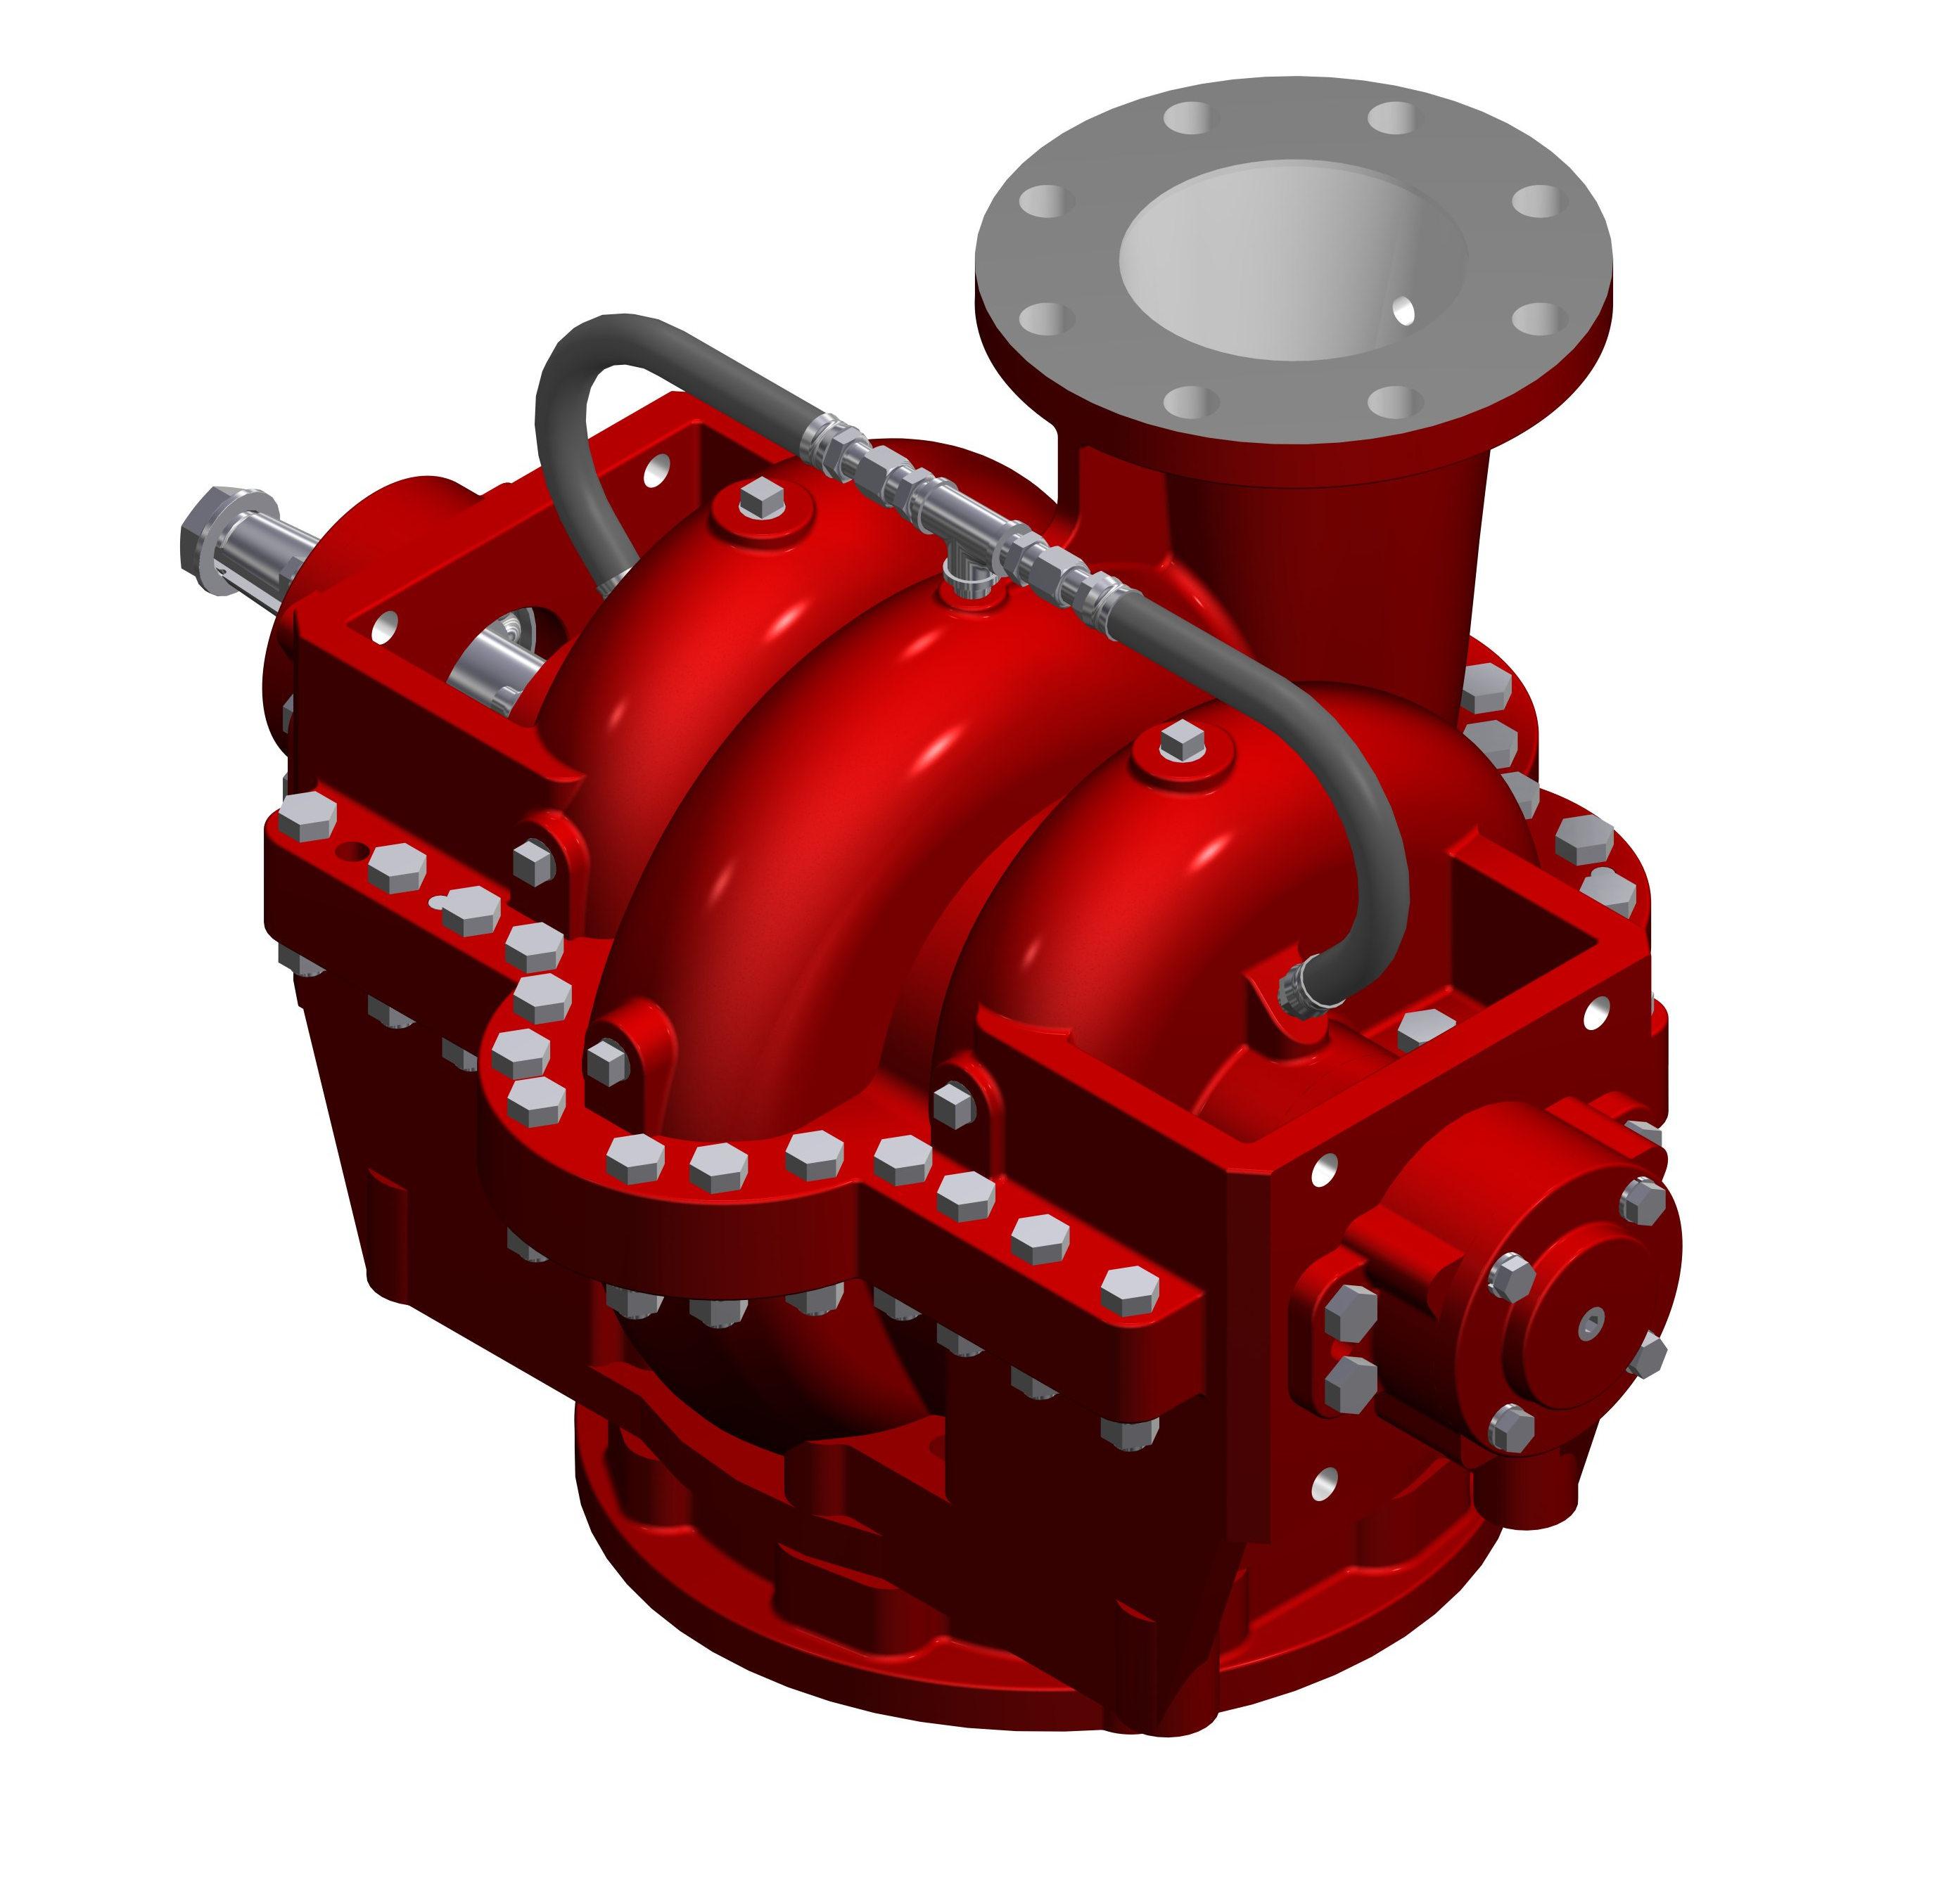

Pump Features
- Horizontally-split bronze volute body and head
- Bronze, fully-enclosed, double-hubbed impeller
- 1704 Stainless steel impeller shaft or Monel (CHK4 only)
- Replaceable wear rings to increase pump life
- Mechanical Seal
- 8-inch ANSI intake flange (bronze) with adapter or 10-inch flanges (less adapter)
- 5-inch discharge flange.

Available with a K Series Transmission or with a 1-3/8 inch tapered input shaft for direct mounting.

Dimensions

Model | Length (in/cm) | Width (in/cm) | Height (in/cm)
CHK-4 | 27.75 (70.5) | 20 (51) | 19 (48.25)
CHD-4 | 28 (71) | 20 (51) | 19 (48.25)

Warranty

Waterous Five-Year Limited Warranty

Conditions of Sales
For details on Waterous Condition of Sales, refer to F-2190, Conditions of Sales located on the Waterous web site at www.waterousco.com or by contacting Waterous.

CHD-4 Shown

The S100 is backed by a Waterous Five-Year Limited Warranty.

For details on Waterous Conditions of Sales, refer to F-2190, Conditions of Sales located on the Waterous web site at www.waterousco.com or by contacting Waterous.

Optional Equipment (see next page)
- Priming System
- Pressure Control Systems – Discharge and Intake Relief Valves
- Corrosion Protection – Zinc Intake Screens and Anodes
- Overheat Protection Manager
- Drain Valves
- Discharge Valves
- Five-Year Limited Warranty with Total Protection Package (TPP-5)
- Transmission Available:

  - K Series Transmission with 1-3/8-inch tapered input shaft for direct mounting

Industry Leading Sales and Support

When you purchase equipment, not only do you get quality products, you get quality service. Our expert service technicians are the best in the business and they are always happy to answer any service questions you might have.
Sales/Applications Assistance Service Assistance
Phone: 651-450-5234 (Press 3) Phone: 651-450-5200
pumpsales@waterousco.com Fax: 800-488-1228
service@waterousco.com

RAISING THE BAR ON INNOVATION, RELIABILITY AND SERVICE.
SPECIFICATIONS - arff: mODEL ch-4

Accessories & Optional Equipment

The accessories below are available for Waterous CH-4 pumps. For detailed information about these accessories, request each specification sheet by number.
Five-Year Limited Warranty with Total Protection Package (TPP-5)
The Five-Year Limited Warrant with Total Protection Package is a comprehensive warranty that increases your standard warranty to include labor expenses to dismantle, remove and reinstall covered products or parts, F-2626.
Primer
Select an electric rotary vane primer for fast, reliable priming, F-2418.
Pressure Control Systems
Discharge Relief Valve
Simple ON-OFF control permits placing the system in or out of operation in seconds. See Relief Valve, F-897.
Intake Relief Valves
The Waterous intake relief valve is designed to dump excess pressure from the inlet side of the pump. See Intake Relief Valves, F-2192.
Corrosion Protection
Waterous offers replaceable zinc intake screens and anodes to provide corrosion protection. These items are designed to sacrifice the zinc element to galvanic corrosion. Without this protection, galvanic corrosion may damage the iron pump body and fittings.
Overheat Protection Manager
The OPM consists of an illuminated warning light on the operator's panel whenever the pump approaches an overheat condition, F-2422.
Drain Valves
Drains all points of the pump simultaneously with the operation of a single control, F-1158.
Discharge Valves
The following Waterous ball-type discharge valves are available: 2-1/2 inch, 3-1/2 inch, rack and sector push-pull, worm gear and electric. Chrome- plated brass ball and hydraulically-balanced seal assembly standard. See Discharge Valves, F-1161.
Oil Cooler Piping
The oil cooler piping is a length of copper tubing that is routed through the transmission. Water from the pump is circulated through this tubing to cool the transmission.

Pump Specifications
Volute Body and Head:

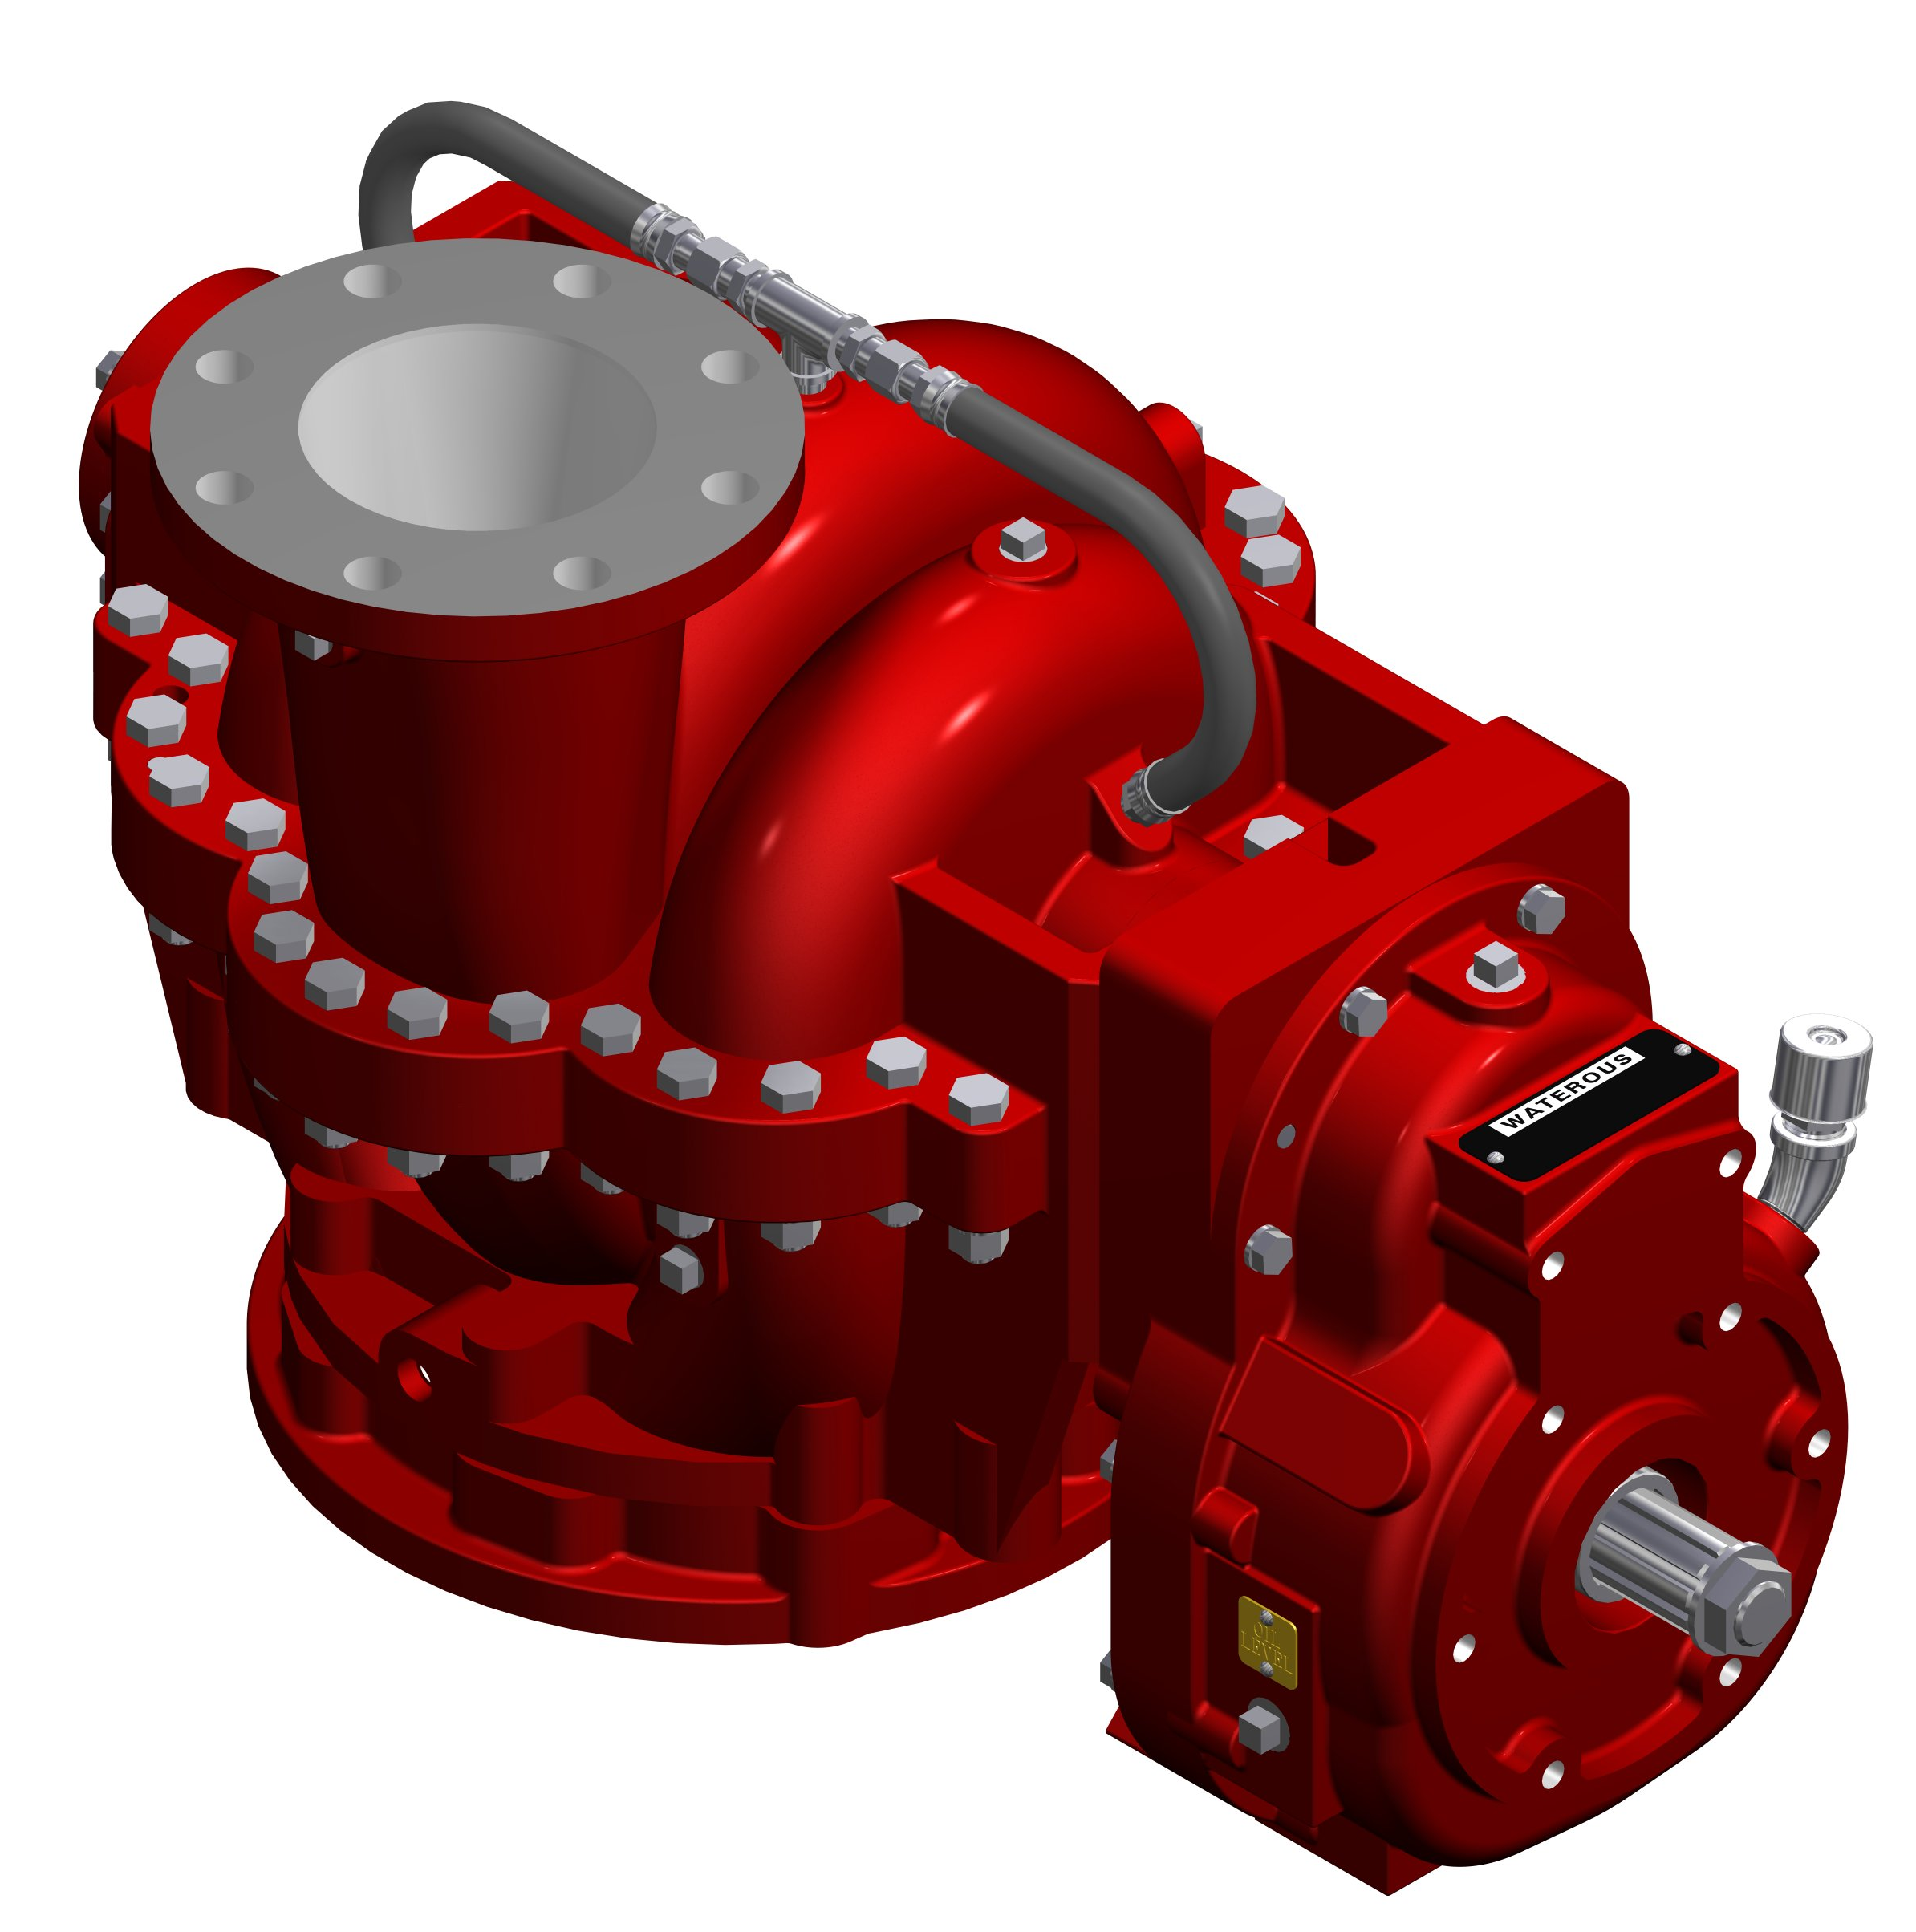
Horizontally-split, bronze (also available in high-tensile gray iron)
Impeller:
Bronze, fully-enclosed, double-hubbed to balance hydraulic thrust, mechanically balanced to eliminate vibration.
Wear Rings:
Replaceable wear rings to increase pump life and keep maintenance costs at a minimum.
Impeller Shaft:
17-4 stainless steel (CHK4 and CHD4) or Monel (CHK4 only), heat treated, ground to precise size and polished under shaft seal. Fully supported by anti-friction bearings.
Shaft Seal:
Mechanical Seal is standard.
Intake Connection:
8-inch ANSI intake flange (bronze) with adapter or 10-inch flange (less adapter)
CHK-4 Shown
Discharge Connection:
5-inch discharge flange
Bearings:
All bearings are oil or grease lubricated, ball-type, located outside the pump casting to accurately align and support the impeller shaft assembly. Ball bearings are deep-groove type designed to carry both radial and axial thrust.

Pump Transmission:

K Series
The K Series Transmission is normally used when a truck transmission mounted power take-off is selected as the pump drive.
Housings: High-tensile gray iron, two-piece, vertically-split
Ratios: 2.26, 2.12, 2.00, 1.69, 1.42, 1.27
Input Shaft: Shaft is hardened and ground alloy steel 1-3/8 inch SAE 10 spline.
Gears: Constant mesh, helical gears made of alloy steel. All gears are crown shaved, carburized, hardened and have ground bores. Splash lubricated.
Bearings: Ball bearings are deep-groove type designed to carry both radial and axial thrust.

