SPECIFICATIONS – PTO Driven: Model CL
NFPA Rated Capacity of 500 GPM (1900 l/min)


The CL pump is compact and lightweight, with a one−piece design that makes it easy to service and maintain.

CL Pump Performance
Rating | GPM | l/min | l/sec | PSI | bar | kPa | MPa
NFPA | 500 | 2000 | 30 | 150 | 10 | 1000 | 1.0
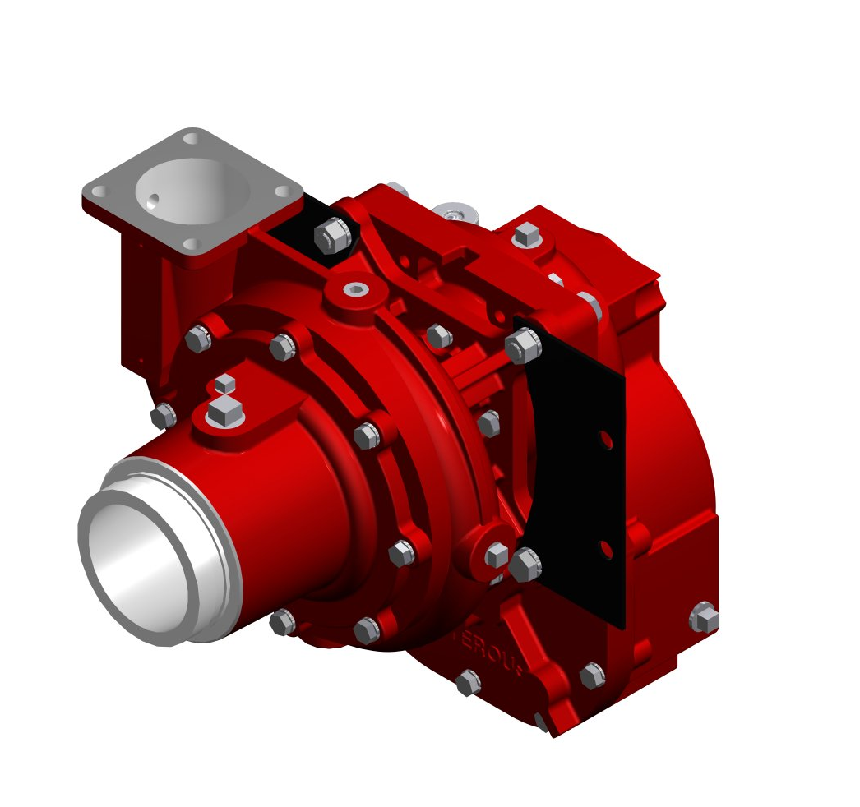

Pump Features
- One-piece, high-tensile ductile iron body (bronze optional on CLV only)
- Bronze, double-hubbed mechanically-balanced impeller
- Stainless steel impeller shaft
- Replaceable wear rings to increase pump life
- Mechanical Seal
- 5-inch discharge flange
- Intake Connection (Choice of the Following):

Type | Model | Sizes
Threaded End Intake | CLR | 4 inch NH or BSP
Victaulic® Intake | CLV | 4 inch

Approximate Weight and Dimensions
(Width & Height dimensions refer to picture shown on front page - less fittings and valves)

Pump/Transmission Model | Intake | Length in/cm | Width in/cm | Height in/cm
CLRK | 4 in. NH | 18-1/8 (46.0) | 15-1/8 (38.4) | 21-1/4 (54.0)
CLRK | 4 in. BSP | 18-3/4 (47.6) | 15-1/8 (38.4) | 21-1/4 (54.0)
CLRT | 4 in. NH | 18-1/4 (46.4) | 17-3/4 (45.1) | 24-3/8 (61.9)
CLRT | 4 in. BSP | 18-7/8 (47.9) | 17-3/4 (45.1) | 24-3/8 (61.9)
CLVK | 4 in. Victaulic® | 18-3/4 (47.6) | 15-1/8 (38.4) | 21-1/4 (54.0)
CLVT | 4 in. Victaulic® | 18-7/8 (47.9) | 17-3/4 (45.1) | 24-3/8 (61.9)

Warranty

Waterous Five-Year Limited Warranty

Conditions of Sales
For details on Waterous Condition of Sales, refer to F-2190, Conditions of Sales located on the Waterous web site at www.waterousco.com or by contacting Waterous.

The S100 is backed by a Waterous Five-Year Limited Warranty.

For details on Waterous Conditions of Sales, refer to F-2190, Conditions of Sales located on the Waterous web site at www.waterousco.com or by contacting Waterous.

CLVK Shown

Optional Equipment (see next page)

- Priming System
- Pressure Control Systems – Discharge and Intake Relief Valves
- Corrosion Protection – Zinc Intake Screens and Anodes
- Overheat Protection Manager
- Drain Valves
- Discharge Valves
- Five-Year Limited Warranty with Total Protection Package (TPP-5)
- Tachometer drive, operates at ½ input shaft speed.
- Transmissions Available:

  - K Series Gear Driven (PTO Driven)
  - T Series Gear Driven (Direct Drive)

Industry Leading Sales and Support

When you purchase equipment, not only do you get quality products, you get quality service. Our expert service technicians are the best in the business and they are always happy to answer any service questions you might have.
Sales/Applications Assistance Service Assistance
Phone: 651-450-5234 (Press 3) Phone: 651-450-5200
pumpsales@waterousco.com Fax: 800-488-1228
service@waterousco.com

RAISING THE BAR ON INNOVATION, RELIABILITY AND SERVICE.
SPECIFICATIONS – PTO Driven: mODEL CL

Accessories & Optional Equipment

The accessories below are available for Waterous CL pumps. For detailed information about these accessories, request each specification sheet by number.
Primer
Select an electric rotary vane primer for fast, reliable priming. F-2418
Pressure Control Systems
Discharge Relief Valve
Simple ON-OFF control permits placing the system in or out of operation in seconds. See Relief Valve, F-897.
Intake Relief Valves
The Waterous intake relief valve is designed to dump excess pressure from the inlet side of the pump. See Intake Relief Valves, F-2192.
Corrosion Protection
Waterous offers replaceable zinc intake screens and anodes to provide corrosion protection. These items are designed to sacrifice the zinc element to galvanic corrosion. Without this protection, galvanic corrosion may damage the iron pump body and fittings.
Overheat Protection Manager
The OPM consists of an illuminated warning light on the operator's panel whenever the pump approaches an overheat condition. F-2422
Drain Valves
Drains all points of the pump simultaneously with the operation of a single control. F-1158
Discharge Valves
The following Waterous ball-type discharge valves are available: 2-1/2 inch, 3-1/2 inch, rack and sector push-pull, worm gear and electric. Chrome- plated brass ball and hydraulically-balanced seal assembly standard. See Discharge Valves, F-1161.
Tachometer
Tachometer drive available; operates at 1/2 input shaft speed.
Five-Year Limited Warranty with Total Protection Package (TPP-5)
The Five-Year Limited Warrant with Total Protection Package is a comprehensive warranty that increases your standard warranty to include labor expenses to dismantle, remove and reinstall covered products or parts, F-2626.

Pump Specifications
Casing:
One-piece, high-tensile ductile iron (bronze optional on CLV only).
Impeller:
Bronze, fully-enclosed, double-hubbed to balance hydraulic thrust, mechanically-balanced to eliminate vibration.
Wear Rings:
Replaceable wear rings to increase pump life and keep maintenance costs at a minimum.
Impeller Shaft:
Stainless steel, heat treated, ground to precise size, and polished under shaft seal. Fully supported by anti-friction bearings.
Shaft Seal:
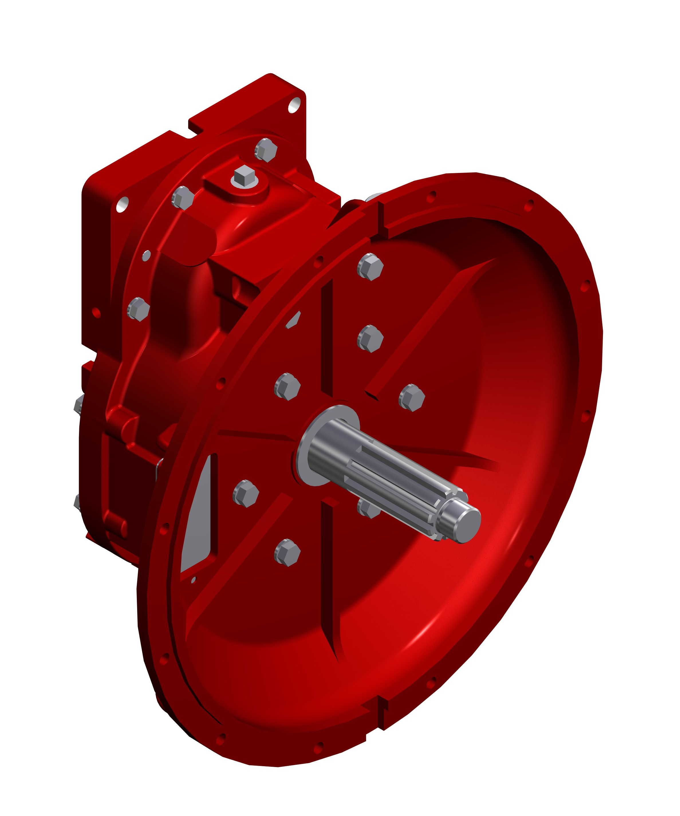
Mechanical Seal is standard.
Intake Connection (Choice of the Following):
Type | Model | Sizes
Threaded End Intake | CLR | 4 inch NH or BSP
Victaulic® Intake | CLV | 4 inch
Discharge Connection:
5-inch discharge flange
Bearings:
All bearings are oil or grease lubricated, ball-type, located outside the pump casting to accurately align and support the impeller shaft assembly. Ball bearings are deep-groove type designed to carry both radial and axial thrust.

Transmission Specifications
IL1526
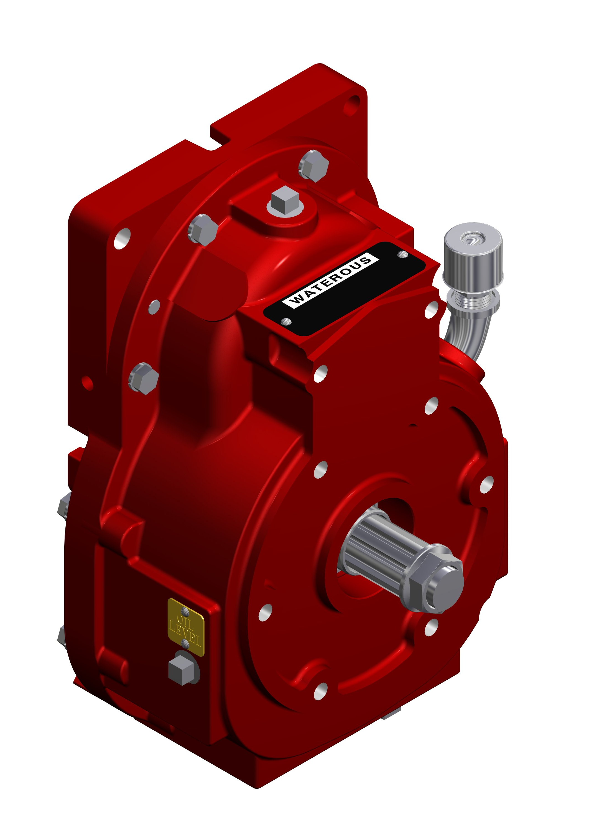
K Series
The K Series Transmission is normally used when a truck transmission mounted power take-off is selected as the pump drive.
Housings: Close-grained, gray iron
Drive Ratios: 1.62, 1.97, 2.14, 2.55, 2.79, 3.40, 4.00, 4.79
Gears: Helical, precision cut, crown shaved for proper load distribution and quiet operation.

T Series
The T Series Transmission is supplied when the pump is to be mounted directly to the engine bell housing. This provides a clean, compact arrangement and allows for complete pump and roll capability.

T Transmissions are available in SAE 2, 3, 4, or 5 bell housing adapters.
Housings: Close-grained, gray iron
Drive Ratios: 1.62, 1.97, 2.14, 2.55, 2.79, 3.40, 4.00, 4.79
Gears: Helical, precision cut, crown shaved for proper load distribution and quiet operation.
Industry Leading Sales and Support

When you purchase equipment, not only do you get quality products, you get quality service. Our expert service technicians are the best in the business and they are always happy to answer any service questions you might have.
Sales/Applications Assistance Service Assistance
Phone: 651-450-5234 (Press 3) Phone: 651-450-5200
pumpsales@waterousco.com Fax: 800-488-1228
service@waterousco.com

