

SPECIFICATIONS – accessories: instrumentation Package
HL Series Fire Pumps

Description:

The Waterous Instrumentation Package includes the following:
- Compound Gauge
- High Pressure Gauge
- Normal Pressure Gauge
- Pump Tachometer/Hourmeter
High Pressure Gauge: Compound Gauge:
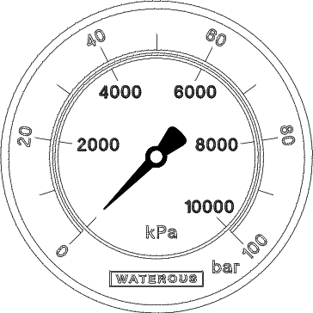
- Dual Scale: 0 to 100 bar / 0 to 10000 kPA
- 1/4 NPT connection
- Brass case with chrome bezel
- Liquid-filled (glycerine/water)
- Panel mount ring
- 90° elbow fitting, 1/4 NPT x 6mm tube (compression)
All gauges and tachometer/hourmeter come as a complete kit and include the manufacturer's installation instructions.

NOTE: The kit does not include a tachometer pick-up, cables or tubing.

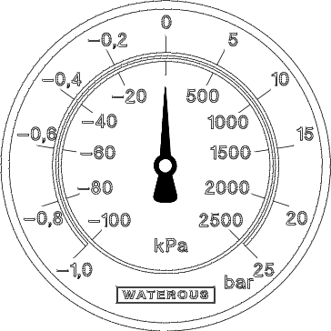
- Dual Scale: -1.0 to 25 bar / -100 to 2500 kPA
- 1/4 NPT connection
- Stainless steel case and bezel
- Liquid-filled (polybutene)
- Panel mount ring
- 90° elbow fitting, 1/4 NPT x 6mm tube (instant)

Pump Tachometer / Hourmeter: Normal Pressure Gauge:

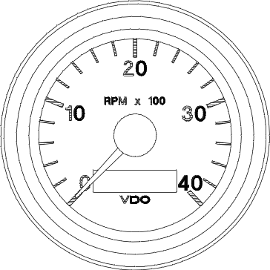
- Range: 0 to 4000 RPM
- Plastic case with black bezel
- Panel mount ring
- 11-32 volt DC operating range
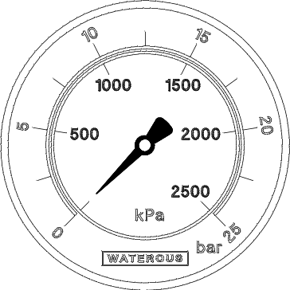
- Dual Scale: 0 to 25 bar / 0 to 2500 kPA
- 1/4 NPT connection
- Brass case with chrome bezel
- Liquid-filled (glycerine/water)
- Panel mount ring
- 90° elbow fitting, 1/4 NPT x 6mm tube (instant)

Shipping Information:

Package Weight: 3.0 Kg (6.7 lb)
Package Size: 26.6 x 26.6 x 19 cm (10-1/2 x 10-1/2 x 7-1/2 in.)

Industry-Leading Sales and Support

When you purchase Waterous equipment, not only do you get quality products, you get quality service. Our expert service technicians are the best in the business and they are always happy to answer any service questions you might have.
Sales/Applications Assistance Service Assistance
Phone: 651-450-5234 (Press 3) Phone: 651-450-5200
pumps@waterousco.com Fax: 800-488-1228
service@waterousco.com

SPECIFICATIONS – instrumentation package

Panel Cut-out Clearances


