

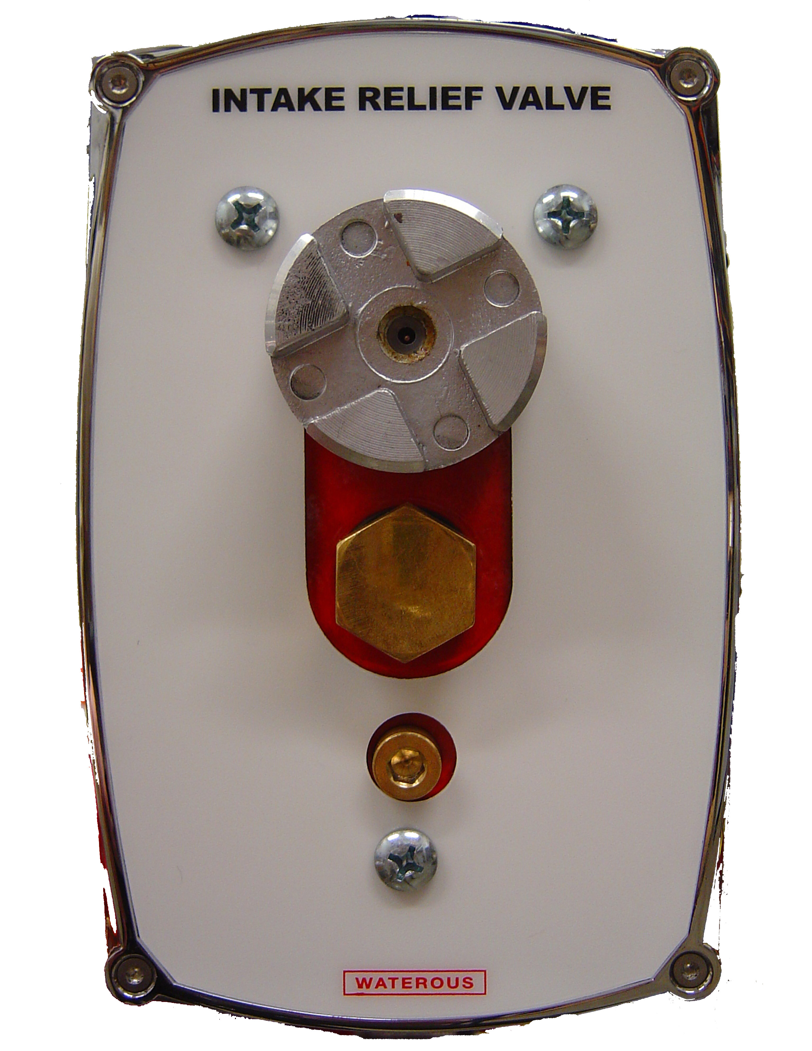
SPECIFICATIONS – accessories: Intake relief valves
Pressure Control
The Waterous Intake Relief Valve system is designed to act as a safety valve by ``dumping'' excess pressure from the inlet side of the pump.

Description:

The Waterous Intake Relief Valve system makes it less likely that ``water hammer'' will burst the supply line, and allows the discharge relief valve or governor system to properly control discharge pressure.

The Waterous Intake Relief Valve system incorporates two separate units for ultimate flexibility in installation and operation: the pilot valve and the main valve. The pilot valve controls operation of the main valve and can be panel mounted to be easily field adjusted for varying operating conditions, or compartment mounted and preset for a specific pressure. It includes a removable strainer and removable needle valve for easy servicing.

The main valve is a sliding piston type valve mounted on the pump inlet, with its outlet terminating in a 2-1/2 inch Victaulic® connection which the apparatus builder can pipe to an appropriate location. Being pilot valve controlled, it can go from closed to full open with very small pressure rise in the pump inlet.

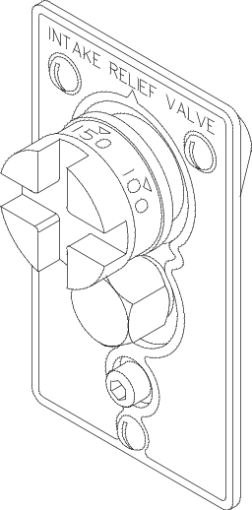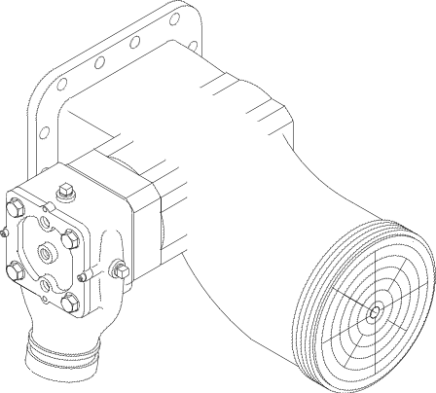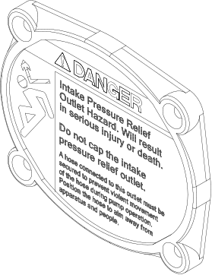

PILOT VALVE:
Mounted on the pump control panel.

RELIEF VALVE:
Mounted on pump suction fitting.

Relief Valve Outlet Warning Plate

Industry-Leading Sales and Support

When you purchase Waterous equipment, not only do you get quality products, you get quality service. Our expert service technicians are the best in the business and they are always happy to answer any service questions you might have.
Sales/Applications Assistance Service Assistance
Phone: 651-450-5234 (Press 3) Phone: 651-450-5200
pumps@waterousco.com Fax: 800-488-1228
service@waterousco.com

SPECIFICATIONS - accessories: Intake Relief Valve

Special Features

Among the features that make the Waterous intake relief valve system reliable and simple to use and maintain are:

- Corrosion resistant bronze and stainless steel used in all critical areas throughout the system.
- Easily serviced with strainer and needle valve readily accessible on panel.
- Smooth turning adjustment knob with ``cross-slot'' to accommodate a spanner wrench or similar flat tool.
- Calibrated from 50 psi to 250 psi.
- Remote mounted pilot valve for quick response and flexibility in installation.
- Relief valve installed and tested by pump manufacturer.

Schematic Showing Relief Valve Operation


