SPECIFICATIONS: Vehicle Mounted: cSU
Single Stage Centrifugal Fire Pump


CSU Pump Performance
 | FLOW |  |  | PRESSURE
Rating | GPM | l/min | l/sec | PSI | bar | kPa | MPa
Rating | 1500, 1750, 2000, 2250 | 6000, 7000, 8000, 9000 | 100, 120, 130, 150 | 150 | 10 | 1000 | 1.0
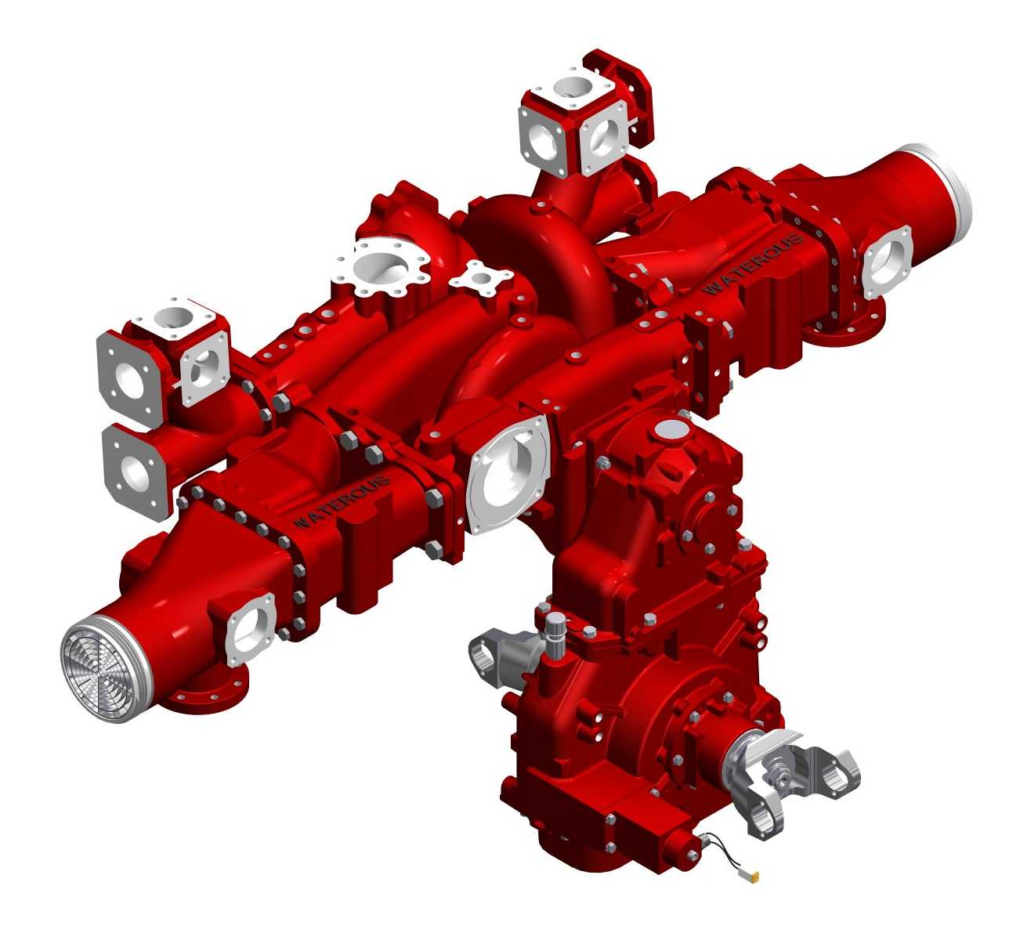
Pump Features
- Two-piece, horizontally-split body
- Lower center of gravity, more room for hose reels, hose beds and other equipment
- Diametrically opposed dual stripping edges
- Double-intake impeller balance radial and axial forces for smooth operation and longer life.
- Flame-plated Impellers
- Reverse-flow, labyrinth-type wears rings for longer pump life
- Braided-flexible graphite (BFG) packing improves heat dissipation, reduces maintenance and minimizes shaft wear.
- Two-piece impeller shaft allows true separation of the pump and pump transmission without disassembling either unit, reducing labor time for repair work.

Simple to Operate
- Power shift system engages the pump with indicating lights confirming the shift is complete.
- Single control activates the priming system, automatically opening the priming valve and starting the primer.
- Single ON-OFF control activates the automatic relief valve systems.

Versatility

The Waterous CS pump was designed with versatility in mind. Waterous offers a complete selection of intake and discharge locations and sizes, and overall piping arrangements.

- Discharge locations are available to meet any need, and sizes from 2-1/2 inches to 5 inches are available.
- Extra large discharge system assures you of the most efficient water delivery system available to the fire service.
- Thoroughly tested to meet NFPA and special contract provisions.

Warranty

Waterous Five-Year Limited Warranty

Conditions of Sales

For details on Waterous Conditions of Sales, refer to F-2190, Conditions of Sales located on the Waterous web site at www.waterousco.com or by contacting Waterous.

Optional Equipment (see next page)

- Priming System
- Pressure Control Systems – Discharge and Intake Relief Valves
- Corrosion Protection – Zinc Intake Screens and Anodes
- Overheat Protection Manager
- Drain Valves
- 3-1/2” Tank to Pump Valve
- Discharge Valves
- Pneumatic Shift
- Five-Year Limited Warranty with Total Protection Package (TPP-5)
- Transmissions Available:

  - C20 Chain Drive (Split-Shaft)
  - P Series Chain Drive (PTO Driven)
  - K Series Gear Driven (PTO Driven)
Industry Leading Sales and Support

When you purchase equipment, not only do you get quality products, you get quality service. Our expert service technicians are the best in the business and they are always happy to answer any service questions you might have.
Sales/Applications Assistance Service Assistance
Phone: 651-450-5234 (Press 3) Phone: 651-450-5200
pumpsales@waterousco.com Fax: 800-488-1228
service@waterousco.com

RAISING THE BAR ON INNOVATION, RELIABILITY AND SERVICE.
CSUC20 Shown
SPECIFICATIONS: vehicle mounted: mODEL cSU

Pump Specifications
Casing
Two-piece, horizontally-split, high-tensile, close grained gray iron or bronze (optional). All passageways are carefully matched to assure the very best hydraulic flow characteristics.
Wear Rings
Bronze, reverse-flow, labyrinth-type replaceable wear rings increase pump life and keep maintenance costs to a minimum.
Impellers
Bronze impeller, balanced both mechanically and hydraulically for vibration-free operation. Flame-plated impeller hubs are standard to assure longer life despite the presence of abrasives in the water supply.
Impeller Shaft
Heat-treated stainless steel is ground at all critical areas, polished under packing. An exclusive two-piece impeller shaft allows separation of the transmission from the pump without disassembling either component. This simplifies repair procedures, resulting in less down time.
Bearings
Three deep-groove, anti-friction ball bearings, located outside the pumping chamber, give support and proper alignment to the impeller shaft assembly. Bearings are oil or grease lubricated, completely separated from the water being pumped, and protected by seal housings, flinger rings and oil seals.
Shaft Seal
Seal housings on packed pumps are equipped with braided flexible graphite (BFG) rings held in place by a split bronze gland which is fully removable and adjustable. BFG packing improves heat dissipation, reduces maintenance and minimizes shaft wear. Self-adjusting, spring-loaded mechanical seals are available which eliminate leakage and routine maintenance.
Flinger Rings
Located on the impeller shaft between seal housings and bearing housings, flinger rings provide added protection and keep water and foreign matter out of the bearings.
Oil Seals
Standard lip type for lubrication and additional bearing protection from dirt and water.
Pump Characteristics
The Waterous CSU pump meets or exceeds all requirements of NFPA standard

Pump Transmissions

C20 Series
Housings: High-strength aluminum, three-piece, horizontally-split.
Drive Ratios: 1.27, 1.41, 1.48, 1.58, 1.69, 1.79, 1.88, 1.97, 2.03, 2.27, 2.46
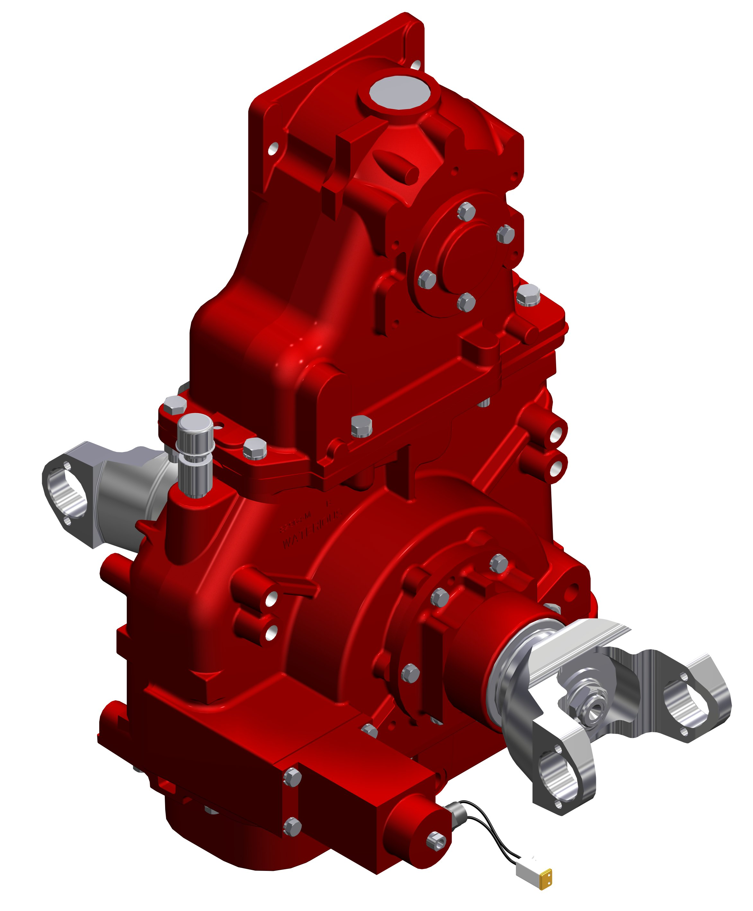
Shafts: Drive line shafts made from alloy steel forgings, hardened and ground to size, 2.35 inch 46-tooth involute spline.
Drive and Driven Sprockets
Made of steel. All sprockets are hardened and have ground bores.
Drive Chain
Morse HV® high-strength involute form chain.
Bearings
Deep-groove, anti-friction ball bearings give support and proper alignment to the impeller shaft assembly. Bearings are oil-splash lubricated, completely separated from the water being pumped, and protected by a V-ring and oil seals.
Lubrication System
An internal lubrication system delivers lubricant directly to the drive chain. This unique design eliminates the need for an external lubrication pump and auxiliary cooling.
Shift Mechanism
Constant-mesh, two-position sliding collar that engages all teeth simultaneously. In-cab controlled pneumatic shift. An internal locking mechanism provides a positive lock in PUMP or ROAD position.
P Series
Housings: Cast aluminum body
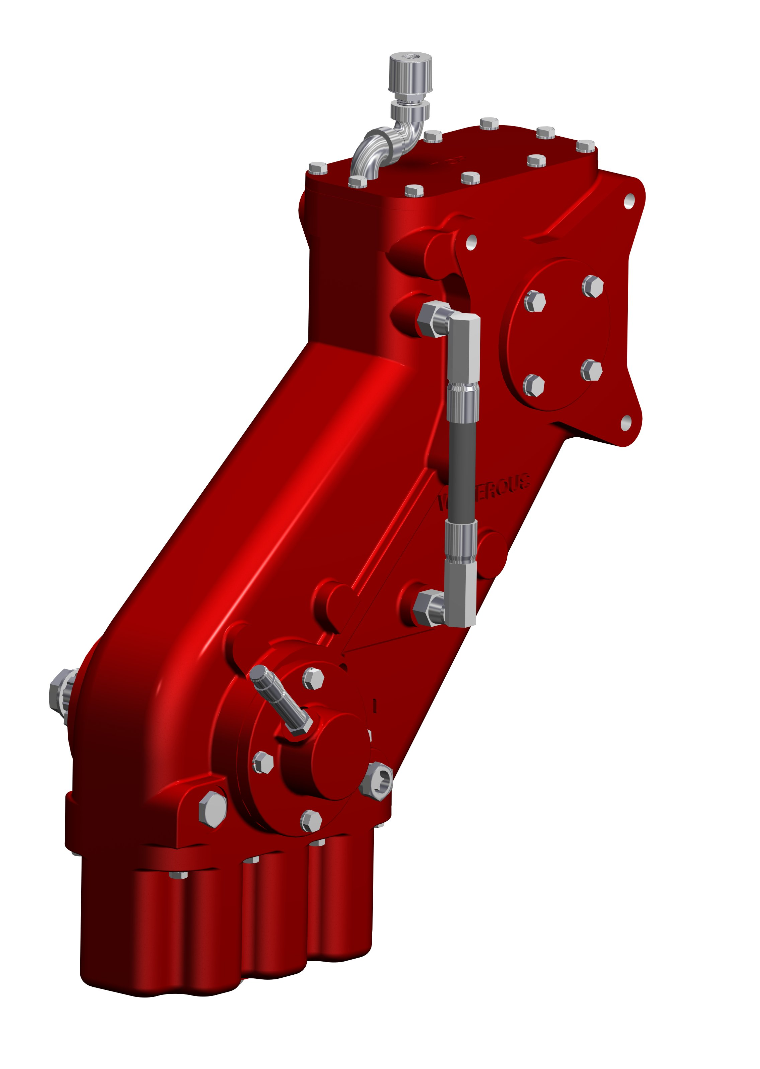
Drive Ratios: 1.71, 1.91, 2.05
Drive & Driven Sprockets
Made of a steel. All sprockets are hardened and have ground bores.
Drive Chain
Morse HV®** high-strength involute form chain.
Bearings
Anti friction ball bearings
Optional Rear Facing Output Shaft
1-3/8-10 SAE spline for Spicer 1280 or 1310 series end yokes

Pump Performance Curves

The accessories below are available for Waterous CSU pumps. For detailed information about these accessories, request each specification sheet by number.
Pneumatic Shift
Air power allows the operator to shift to ROAD or PUMP position by actuating a simple valve. Illuminated LED's signal completion of shift from ROAD to PUMP. See Power Shift, F-1154.
Five-Year Limited Warranty with Total Protection Package (TPP-5)
The Five-Year Limited Warranty with Total Protection Package is a comprehensive warranty that increases your standard warranty to include labor expenses to dismantle, remove and reinstall covered products or parts, F-2626.
Primer
Select an electric rotary vane primer for fast, reliable priming, F-2418.
Pressure Control Systems
Discharge Relief Valve
Simple ON-OFF control permits placing the system in or out of operation in seconds. See Relief Valve, F-897.
Intake Relief Valves
The Waterous intake relief valve is designed to dump excess pressure from the inlet side of the pump. See Intake Relief Valves, F-2192.
Corrosion Protection
Waterous offers replaceable zinc intake screens and anodes to provide corrosion protection. These items are designed to sacrifice the zinc element to galvanic corrosion. Without this protection, galvanic corrosion may damage the iron pump body and fittings.
Overheat Protection Manager
The OPM consists of an illuminated warning light on the operator's panel whenever the pump approaches an overheat condition, F-2422.
Drain Valves
Drains all points of the pump simultaneously with the operation of a single control. F-1158
Tank to Pump Valve
The tank to pump valve is a full-flow 3-1/2 in. diameter ball valve which is attached directly to the pump. The valve is operated by either a 90° spring detent remote control handle or an electric rotary actuator, F-2536.
Discharge Valves
The following Waterous ball-type discharge valves are available: 2-1/2 inch, 3-1/2 inch, rack and sector push-pull, worm gear and electric. Chrome- plated brass ball and hydraulically-balanced seal assembly standard. See Discharge Valves, F-1161.

