
SPECIFICATIONS: vehicle mounted: HL Series
Designed to Pump Both High and Low Pressure Simultaneously

HL Series Pump Performance
 | Low Pressure |  |  |  |  |  |  | High Pressure
Model | GPM | L/min | L/Sec | PSI | Bar | kPa | MPa | GPM | L/min | L/Sec | PSI | Bar | kPa | MPa
HL200 | 500 | 2000 | 33 | 150 | 10 | 1000 | 1.0 | 100 | 400 | 6.5 | 600 | 40 | 4000 | 4.0
HL300 | 750 | 3000 | 50
HL400 | 1000 | 4000 | 65
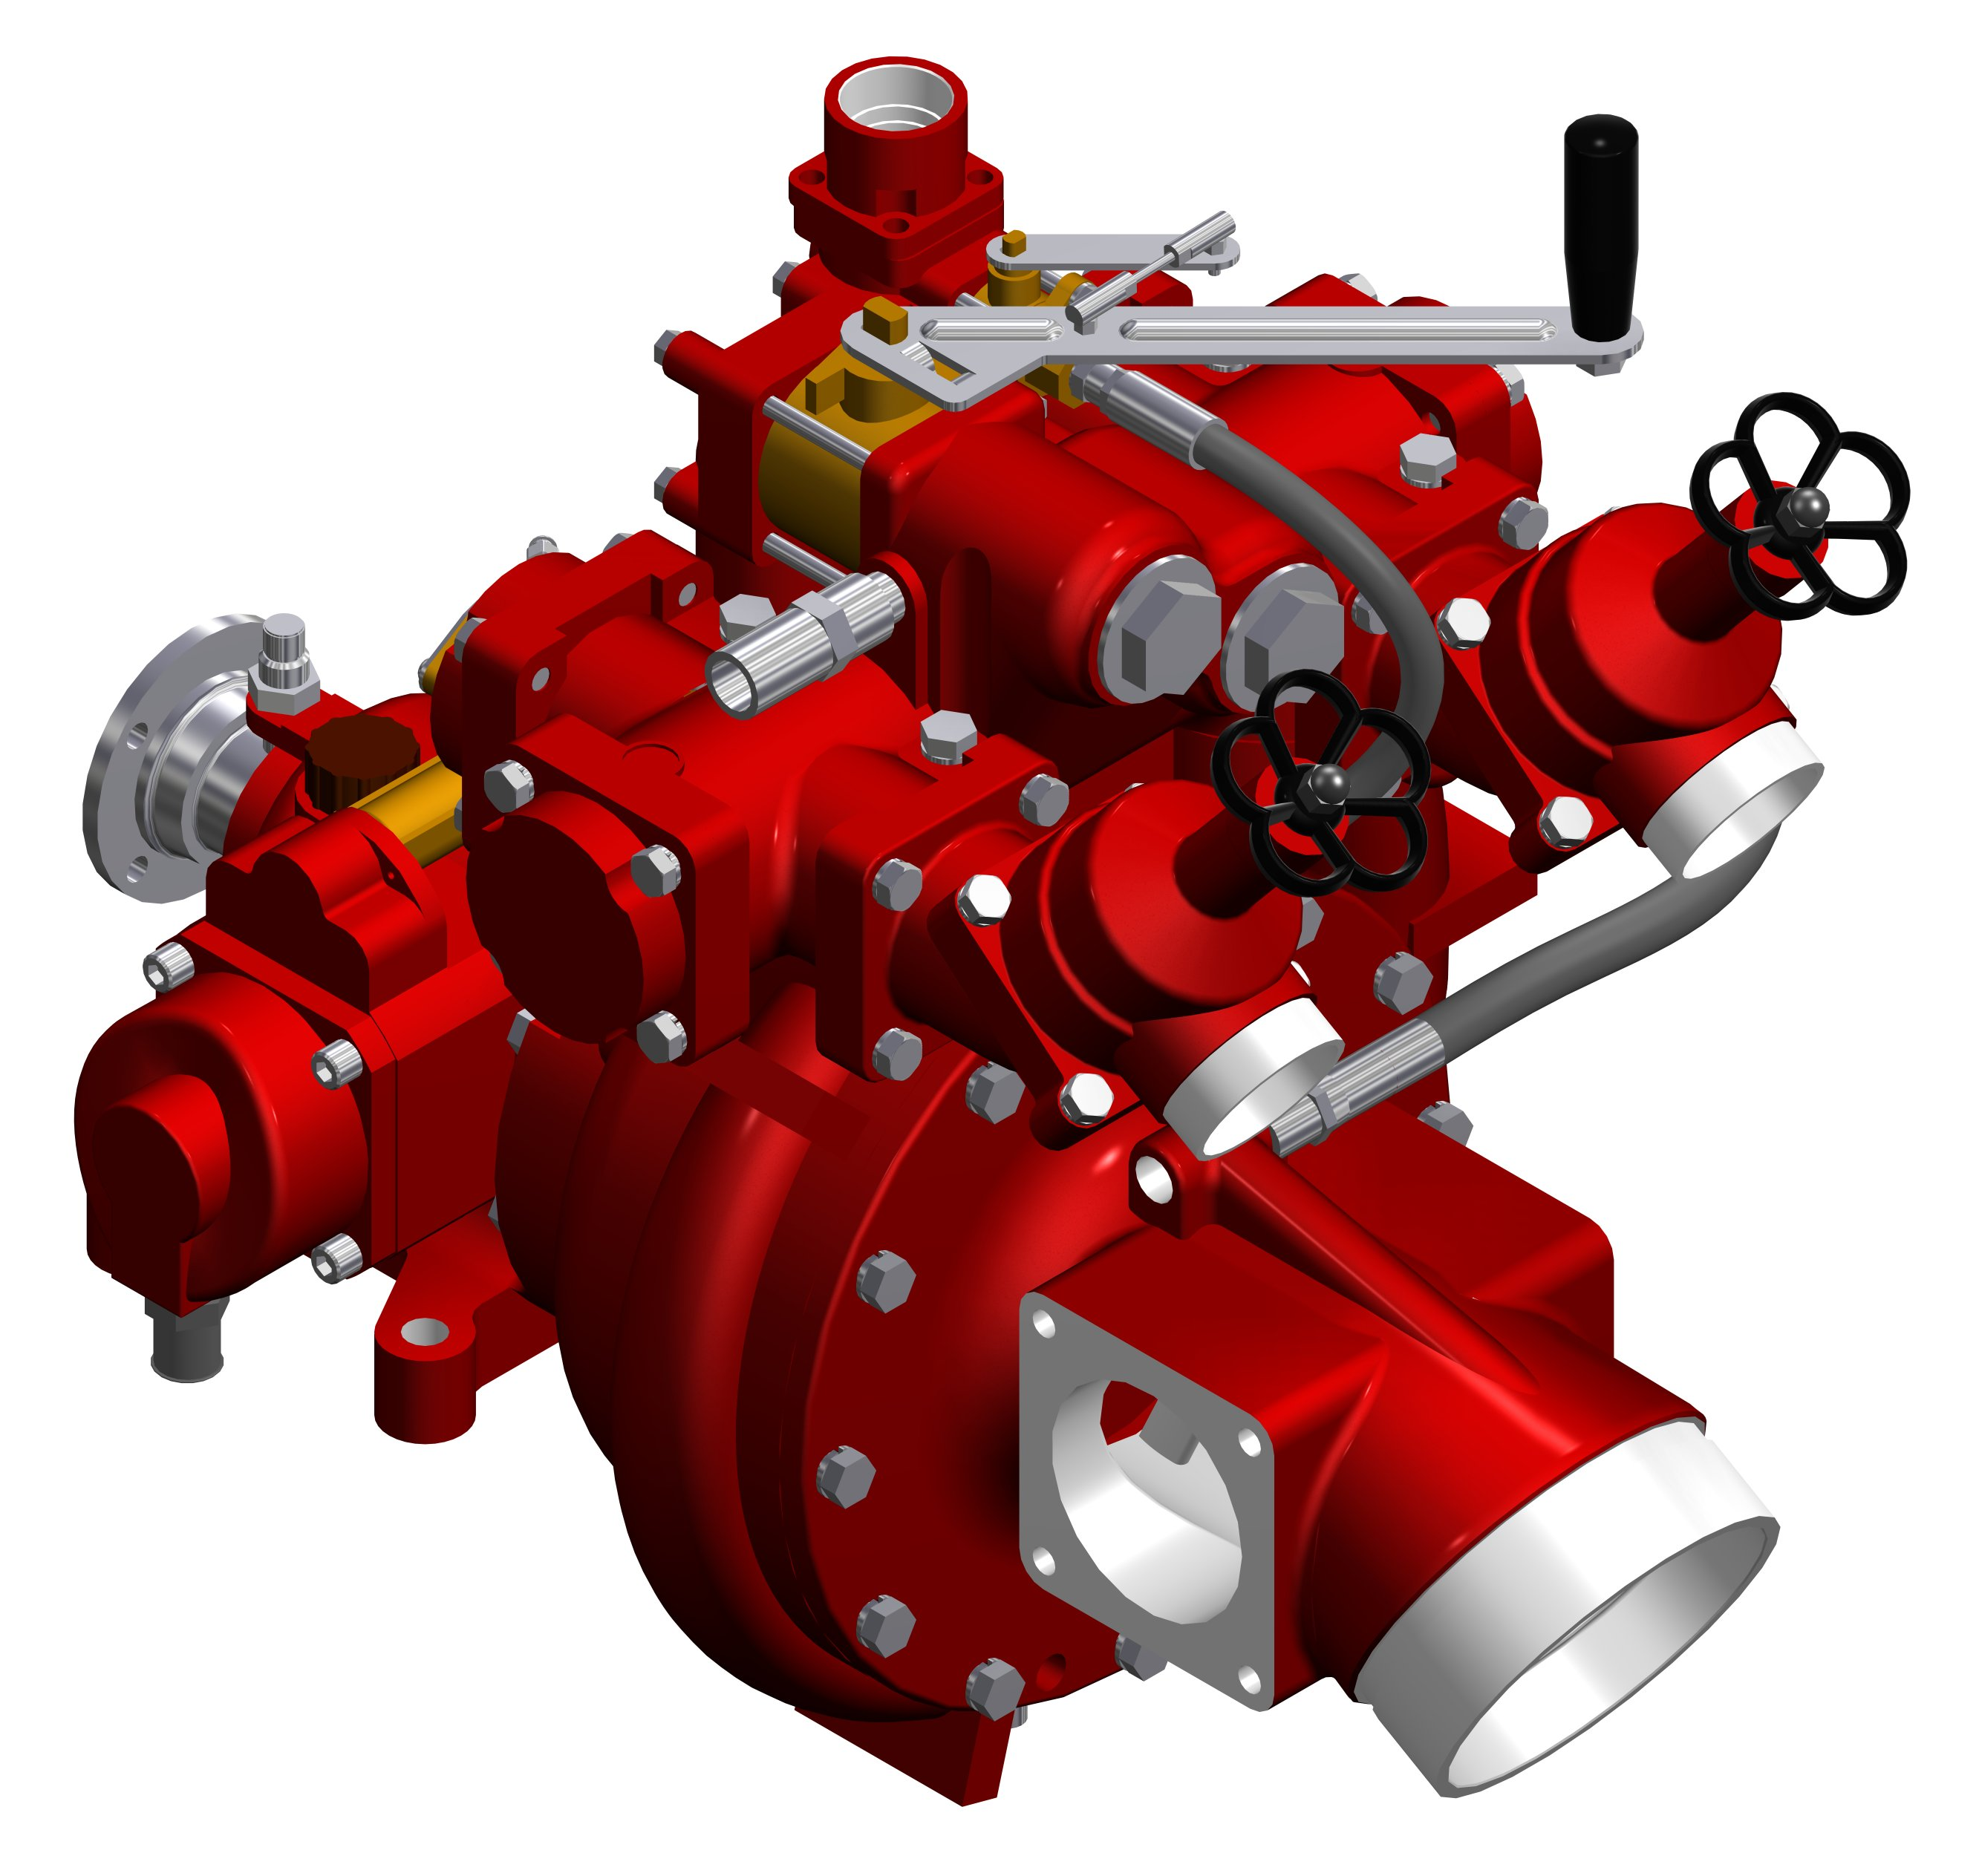
Pump Features
- Designed to pump both high and low pressure simultaneously
- Lightweight, corrosion-resistant construction
- Automatic piston primer
- Automatic thermal relief valve
- Self-adjusting mechanical seal
- Anodized aluminum or bronze intake with 30° droop, two (2) auxiliary 4” side flanges
- Anodized aluminum or bronze discharge manifold with six (6) outlets

HL300 Model

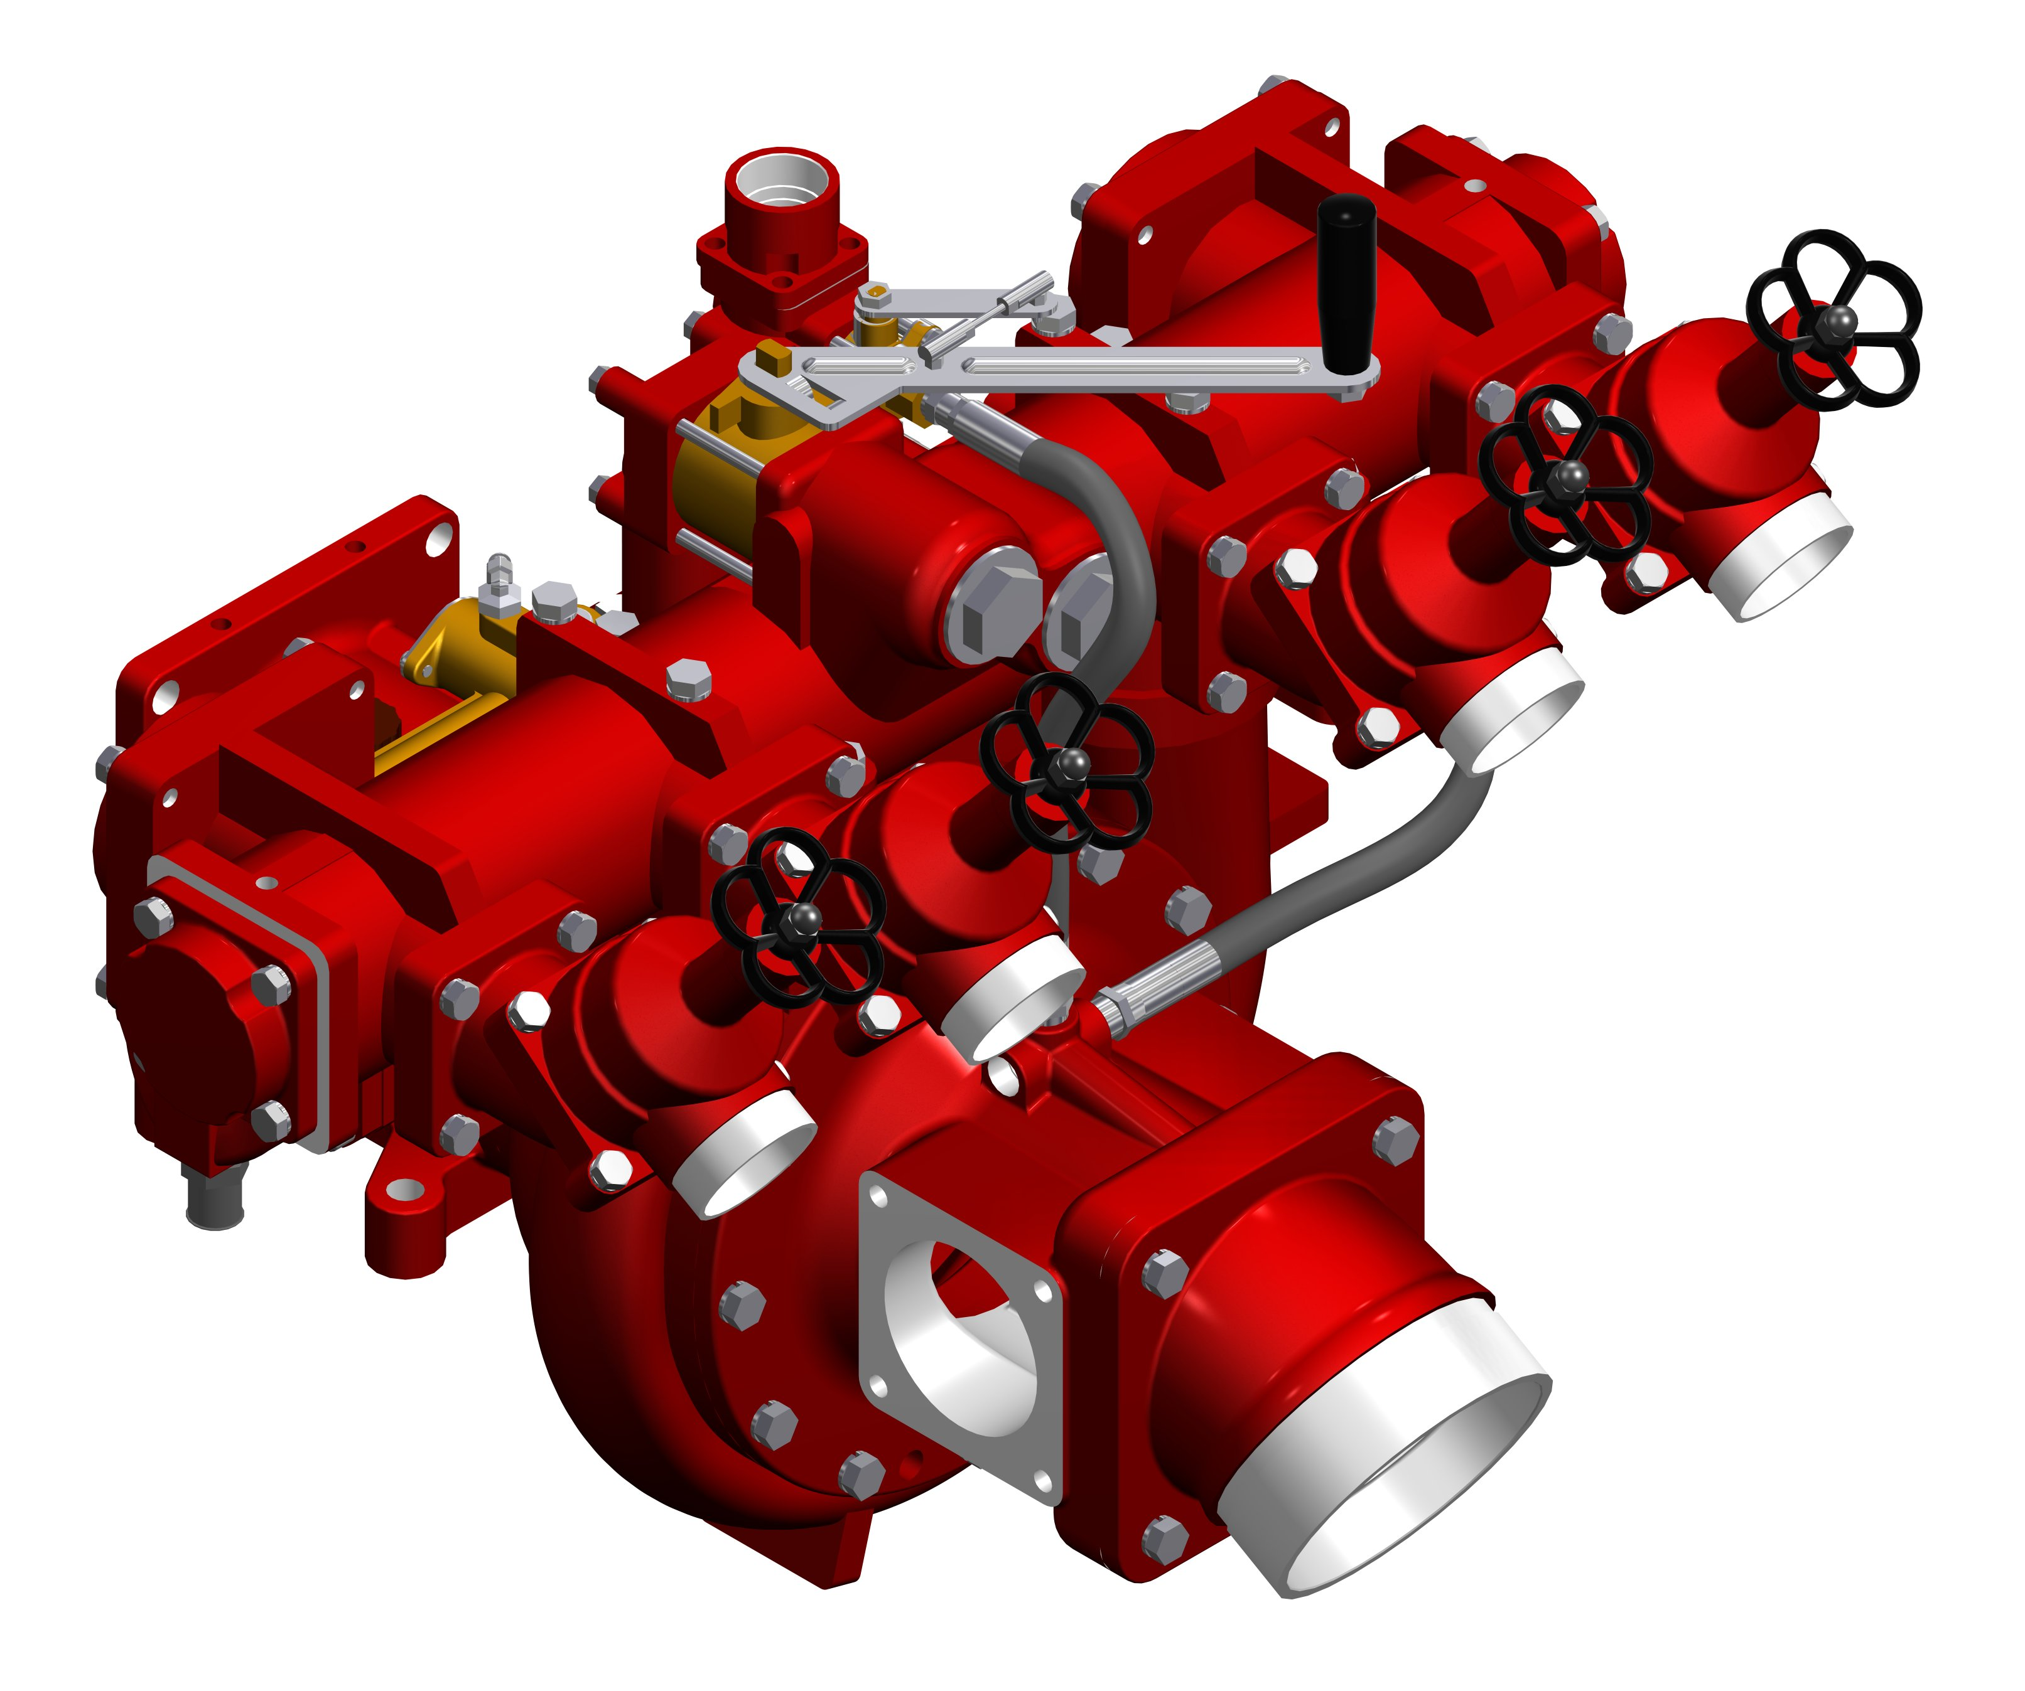

Warranty
Waterous Five-Year Limited Warranty.

Conditions of Sales
For details on Waterous Conditions of Sales, refer to F-2190, Conditions of Sales located on the Waterous web site at www.waterousco.com or by contacting Waterous.
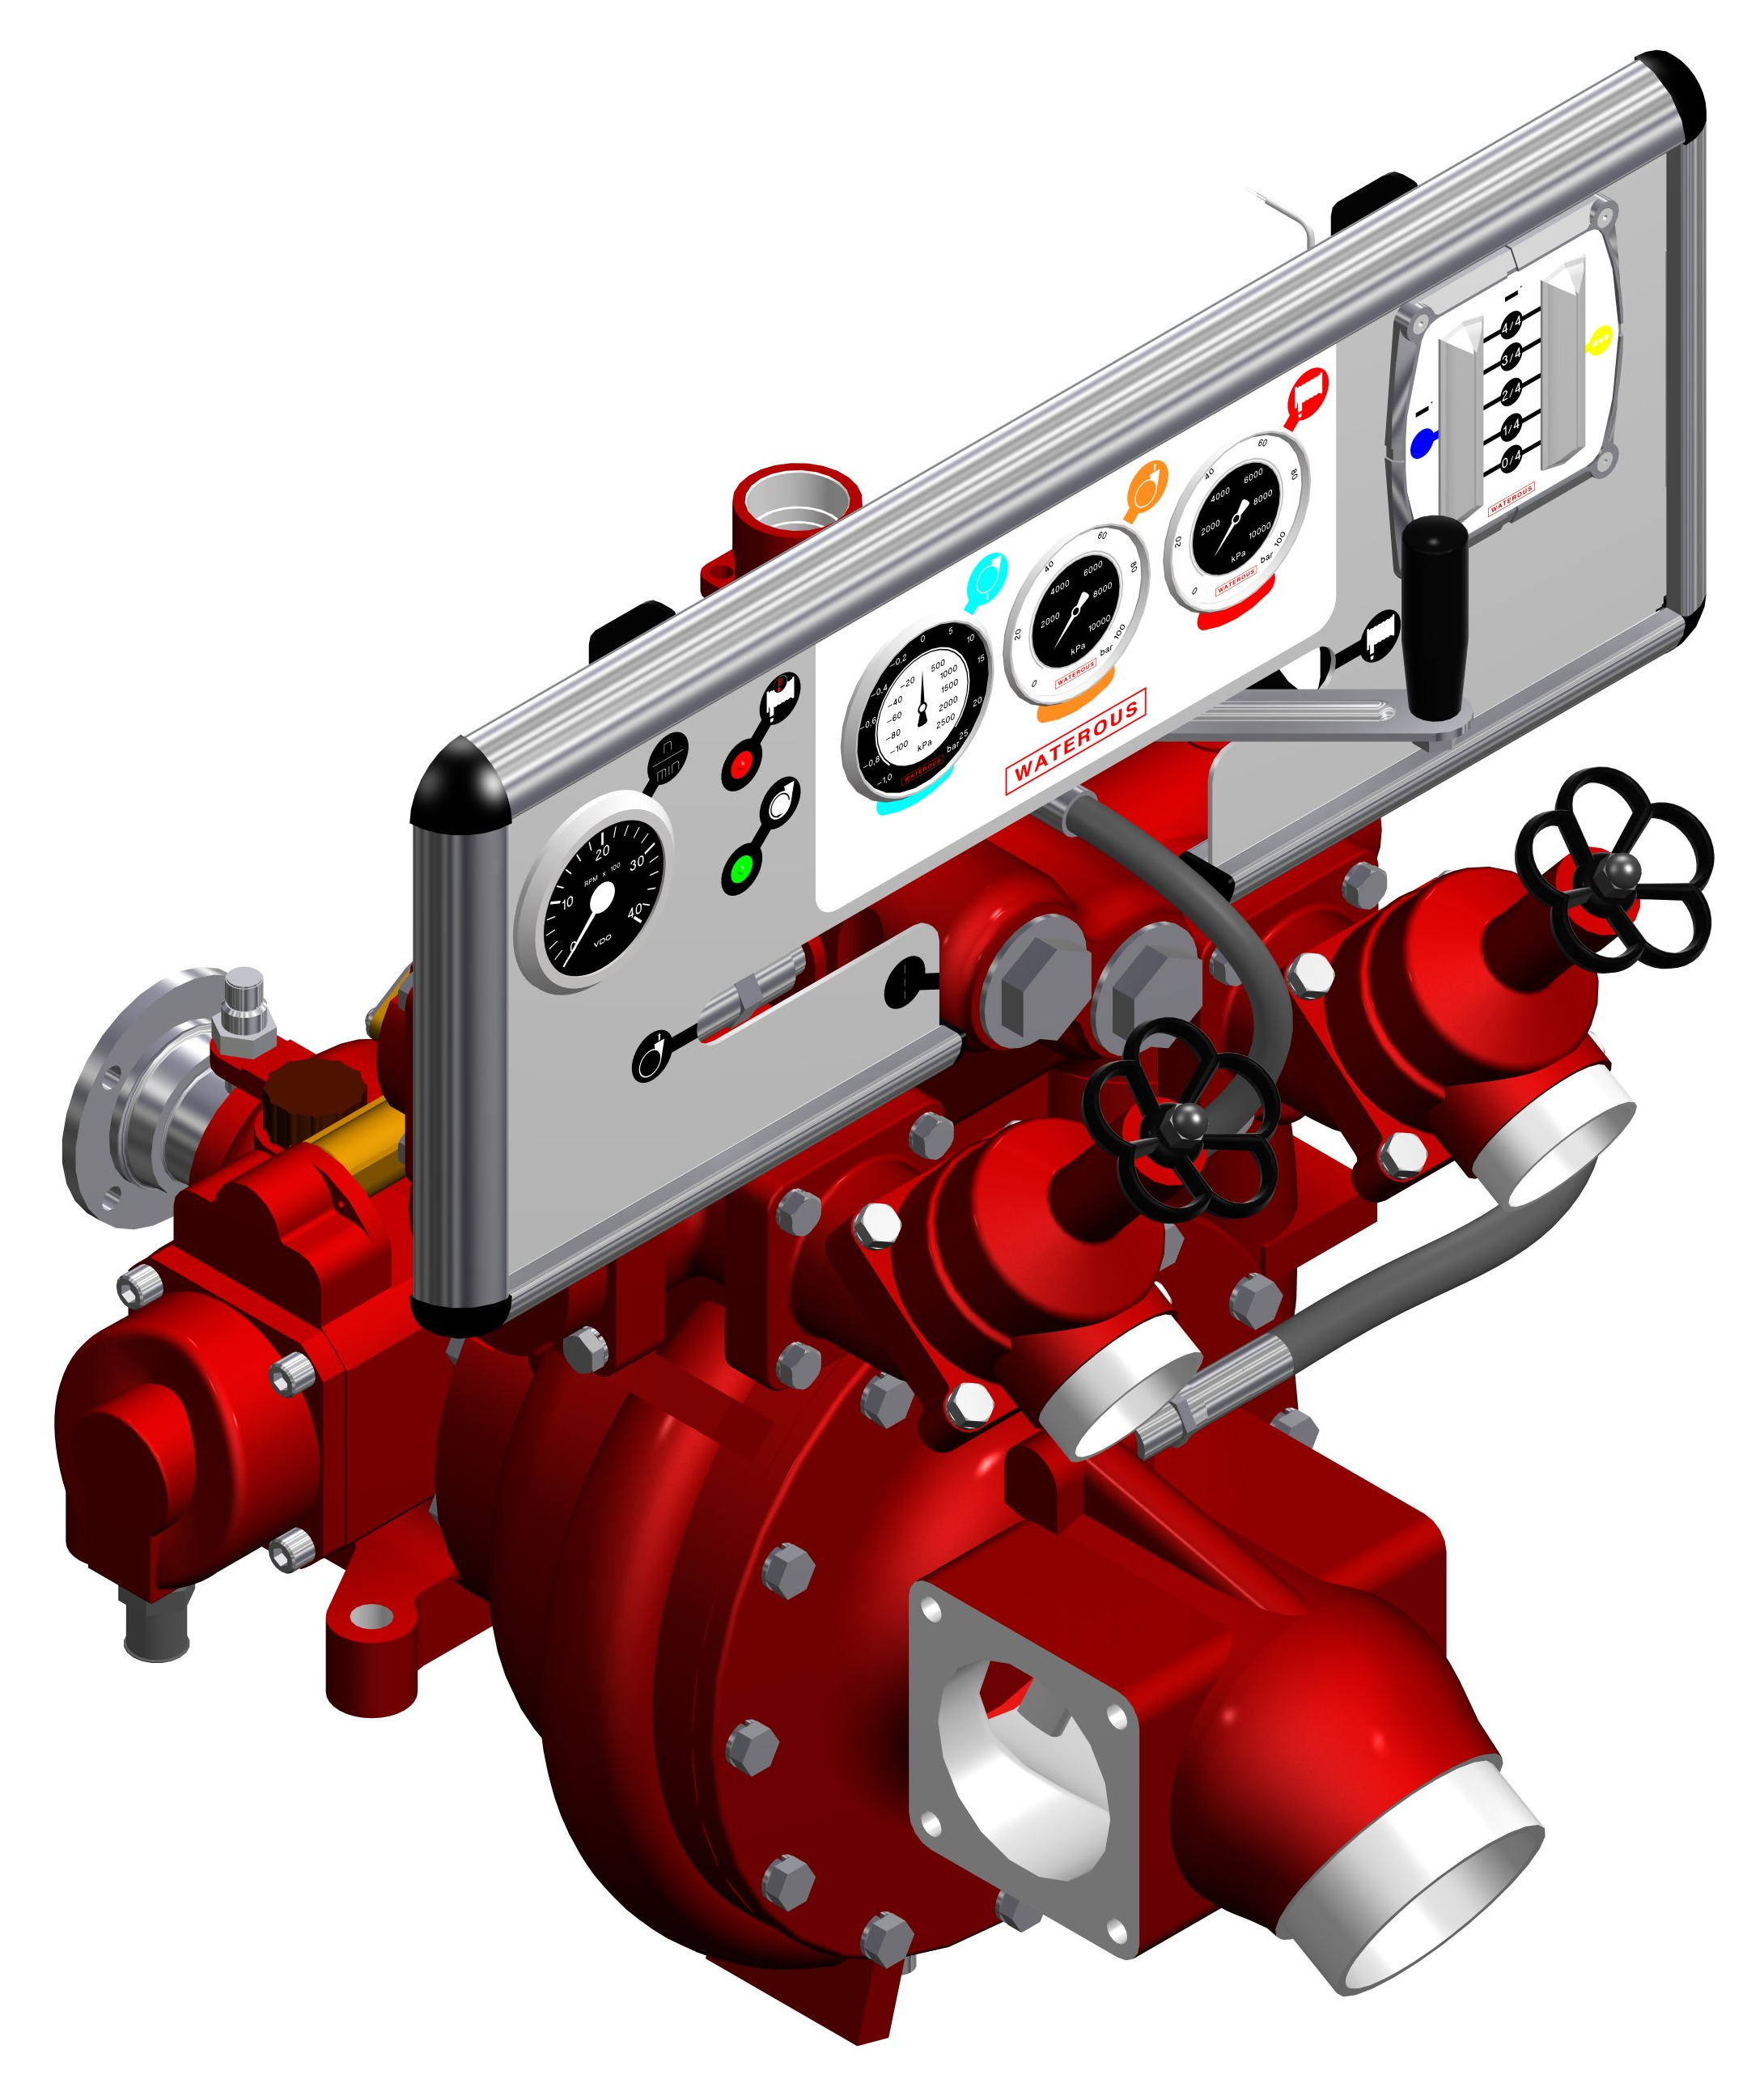

Optional Equipment (See Next Page)

- Round the Pump (RTP) Foam Proportioner
- Instrument Panel
- Corrosion Protection – Zinc Intake Screens and Anodes
- Bronze (Gunmetal) construction
- Transmissions Available:
  - K Series Gear Driven Transmission
- Clockwise and Counterclockwise rotation available (not available on bronze (gunmetal) models.
Industry Leading Sales and Support

When you purchase equipment, not only do you get quality products, you get quality service. Our expert service technicians are the best in the business and they are always happy to answer any service questions you might have.
Sales/Applications Assistance Service Assistance
Phone: 651-450-5234 (Press 3) Phone: 651-450-5200
pumpsales@waterousco.com Fax: 800-488-1228
service@waterousco.com

RAISING THE BAR ON INNOVATION, RELIABILITY AND SERVICE.
HL400 Model
HL200 Model

HL Series Pump Weight
Model | Pounds | kg
HL200 | 218 | 100
HL300 | 227 | 103
HL400 | 275 | 125

SPECIFICATIONS: VEHICLE-MOUNTED: HL Series

Pump Specifications Accessories & Optional Equipment
Pump Body:
Corrosion-resistant anodized aluminum or bronze
Low Pressure Impeller:
Wear-resistant anodized aluminum, flame-plated hubs
High Pressure Impeller:
Bronze
Impeller Shaft:
Stainless steel
Wear Ring:
Bronze
Shaft Seal:
Maintenance-free mechanical seal
Pedestal:
Constructed of anodized aluminum, the pedestal supports the Waterous automatic piston primer and main bearings.
Intake:
Anodized aluminum or bronze with 30°droop, two auxiliary 4” side flanges
- All models available with 5 in. Victaulic®
Discharge Manifold:
Anodized aluminum or bronze with six discharge outlets
Interstage Crossover Valve:
The valve incorporates both a built-in high pressure relief valve and a removable strainer for the high pressure stage inlet

Round the Pump (RTP) Foam Proportioner:
The Waterous RTP Foam Proportioner consists of an eductor, foam proportioning valve and an ON/OFF control valve. When activated, a portion of the pump discharge flow is directed to the eductor, causing a pressure drop in the eductor, which draws foam concentrate through the proportioning valve. The foam mixes with the water flowing through the eductor. The foam solution then enters the pump through the pump intake and finally delivered to the discharge outlets.
Instrument Panel:
Contains High Pressure, Normal Pressure, Compound Pressure Gauges and Tachometer.

K Series Transmission:
The K Series Transmission is normally used when a truck transmission mounted power take-off is selected as the pump drive.
Housing: Close-grained, gray iron
Gears: Helical, precision cut, crown shaved for proper load distribution and quiet operation.
Material:
Bronze construction available.
Total Protection Package (TPP-5)
The Total Protection Package is a comprehensive warranty that increases your standard warranty to include labor expenses to dismantle, remove and reinstall covered products or parts, F-2626.

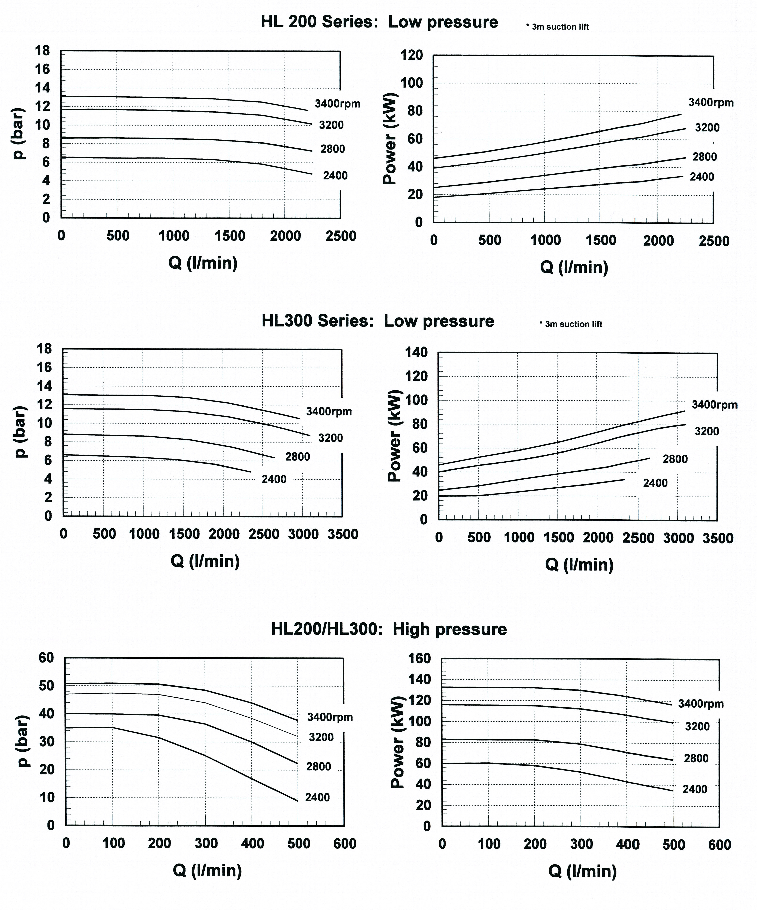
HL400 Series Low Pressure
HL200, HL300 and HL400 High Pressure
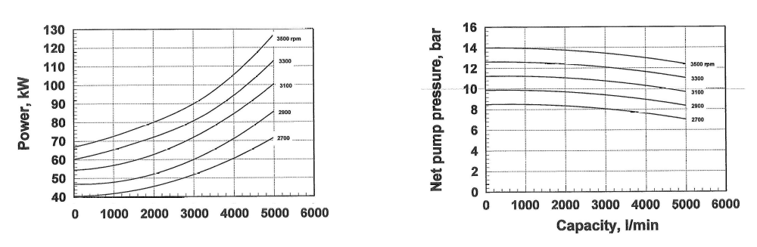
P (bar)

